


A MITEL PRODUCT GUIDE

Unify Phone V3.2
Sales Information

Document Version Number: V13
Document Communication Type: EXTERNAL
Date: 10/2024
Document Status: FINAL



Table of Contents
Overview 5
Brief Product Overview 5
Unify Phone for OpenScape 8
Unify Phone for Microsoft Teams 10
Further Unify Phone integrations 11
Presence Synchronisation Microsoft Teams and Unify Phone 13
Unify Phone for MS Teams Plug-in from the Microsoft Teams App Store 14
Supported Browsers and Mobile Operating Systems 14
Connectivity and Compatible Products 15
Planned Languages 15
Countries 17
Description of Features 22
Customer Benefits 25
Unique Selling Proposition (USP) 26
Implementation and Networking Scenarios 26
Configuration Overview 26
Licensing 29
General Pricing of Unify Phone 33
Unify Phone Evaluation Licenses 34
Overview Unify Phone order Codes 35
User Licenses Required in addition to Unify Phone Licenses 36
SBC Requirements 36
User Management 37
Security 41
Networking Requirements 42
Migration 42
Unify Management Center (UMC) 43
Services 44
Support Services 45
Positioning in Relation to Products in the Unify Product Range 45
Area of Application, Commencement of Marketing and Delivery 46
Customer Information on Commencement of Marketing and Delivery 46
Sales Objectives and Target Groups 46
Target Group 46
Marketing Structure 47
Supporting Sales Information 47
Supporting Sales Information on the Internet 47
Export regulations 48
Client Information on Data Protection and Information Security 48
Client Information on the Training Offer 48
Information on the Training Offer 49

List of Changes
Version | Date | Description
V1 | April 2022 | Unify Phone v1, release of Unify Phone with Unify Video for OpenScape Business
V1.1 | Sept 2022 | Unify Phone v1.1, release of Unify Phone with Unify Video for OpenScape 4000/OpenScape Voice
V2.0 | April 2023 | Unify Phone v2, release of Unify Phone for OpenScape, and rename of previous Unify Phone with Unify Video to Unify Phone for Unify Video
V2.1 | May 2023 | Amended OS Business License requirements
V2.2 | May 2023 | Minor changes status Unify Video for OpenScape since initial release
V2.3 | Aug 2023 | Removal for PSR for OS 4000 and OS Voice  Release of Unify Phone for Microsoft Teams, Changes to OS Business Unify Phone licensing.
V2.4 | Aug 2023 | Updated Links for links / Adding Client Data links for Unify Phone
V2.5 | Feb 2024 | Additional Countries added (NAM/LAM/AUS/NZ), Fixed SSL Release, Updates to Unify Phone client features, additional information on encryption for OS Business, Release of Basque language, Professional Services for Unify Phone, Additional information on Security / Networking Pre-Requisites
V.3.0 | July 2024 | Remove Unify Video support, OS Business Entry package, new Mitel design UI, Profile/Favourites, OS4000 V11 hunt group support, OS Business application integration, Chromebook support, SSL V3 support
 | July 2024 | Service Portfolio update
V3.1 | Aug 2024 | New countries for Sales Partner: Canada, India, Namibia, Singapore, South Africa, Vietnam
 | Aug 2024 | German version available with some corrections for better explanations
 | Sept 2024 | Release of UMC

Notices
The information contained in this document is believed to be accurate in all respects but is not warranted by Mitel Europe Limited. The information is subject to change without notice and should not be construed in any way as a commitment by Mitel or any of its affiliates or subsidiaries. Mitel and its affiliates and subsidiaries assume no responsibility for any errors or omissions in this document. Revisions of this document or new editions of it may be issued to incorporate such changes. No part of this document can be reproduced or transmitted in any form or by any means - electronic or mechanical - for any purpose without written permission from Mitel Networks Corporation.

© 2024 Mitel Networks Corporation. All Rights Reserved. Mitel and the Mitel logo are trademark(s) of Mitel Networks Corporation. Unify and associated marks are trademarks of Unify Software and Solutions GmbH & Co. KG. All other trademarks herein are the property of their respective owners.

Product Description

Overview

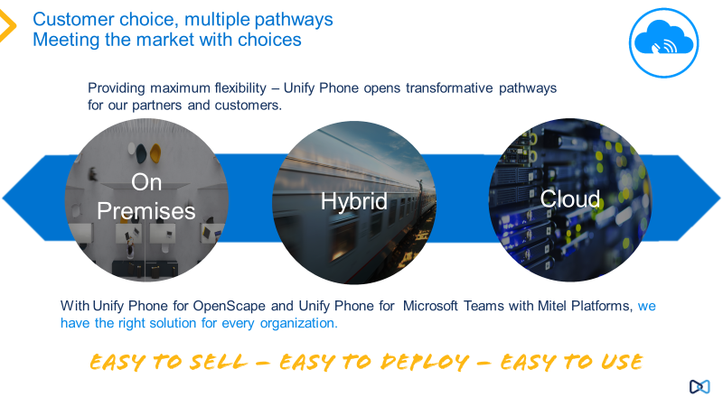
Brief Product Overview

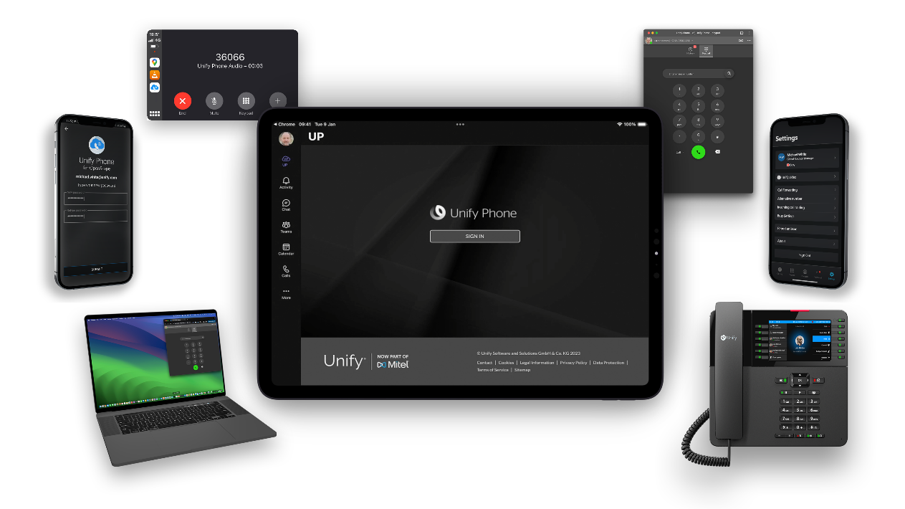

Unify Phone is a cloud based WebRTC telephony connectivity solution for OpenScape platforms, OpenScape Voice, OpenScape 4000 and OpenScape Business.
Unify Phone allows end users to utilize cloud based mobile and web-based clients, to access telephony from their OpenScape platforms.
Unify Phone can be easily deployed onto Unify’s OpenScape platforms (OpenScape Business, OpenScape 4000 and OpenScape Voice). Unify Phone is a cloud-based subscription service, users subscribe via their OpenScape platforms to the Unify Phone service on a price per month basis.
Unify Phone clients are telephony extensions from the OpenScape platform and provide many of the native OpenScape platform benefits and features and allow the retention of existing telephony numbering and the continued use desk phones as Unify Phone can be combined with existing telephony numbers and configurations.
Unify Phone is released in two solution scenarios.
Unify Phone for OpenScape which combines Unify Phone with a customer’s OpenScape platform to provide a hybrid cloud-based telephony solution.
Unify Phone for Microsoft Teams combines Unify Phone with Microsoft Teams to provide an embedded Unify Phone client within Microsoft Teams, with bi-directional presence synchronization.

Solution Overview
Unify Phone is available in two user deployment scenarios.
- Unify Phone for OpenScape
- Unify Phone for MS Teams
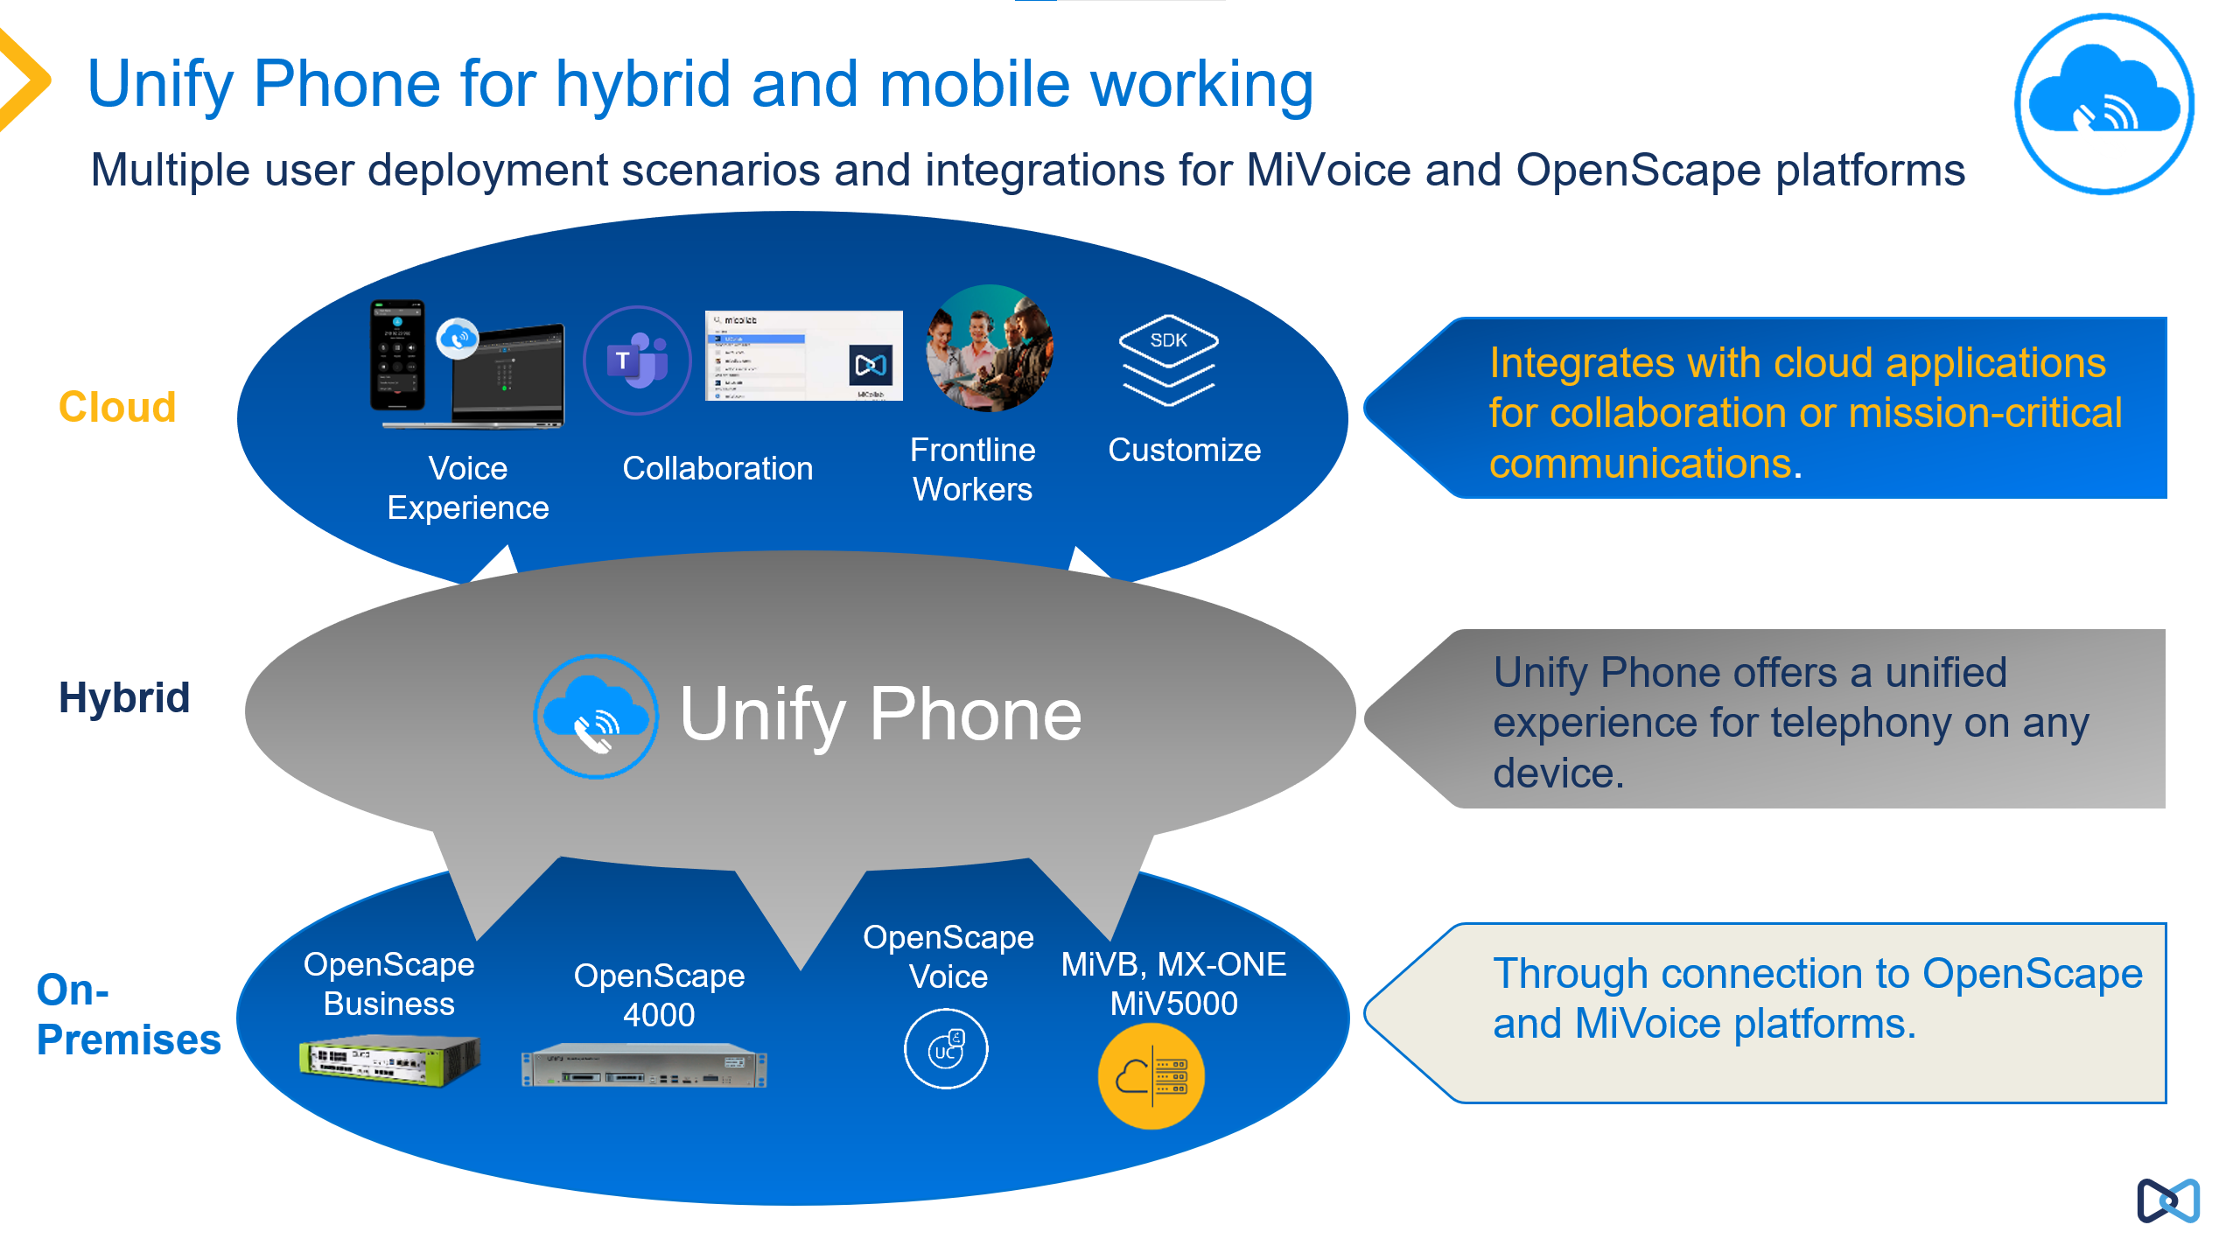
Unify Phone User Solution Scenarios
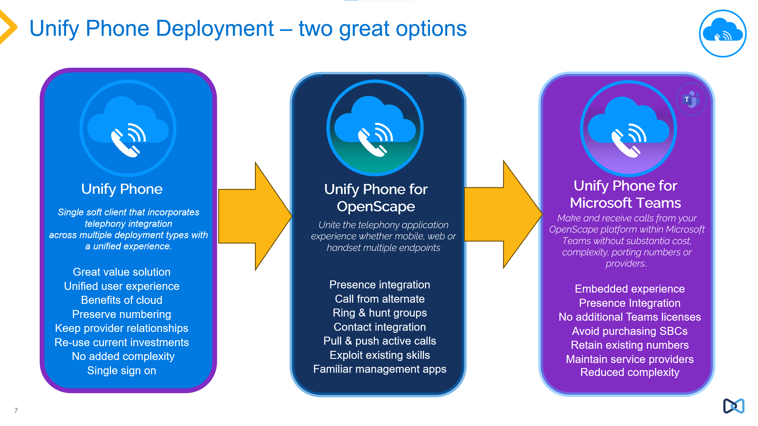
Unify Phone User Deployment Scenarios Key Features

These deployment scenarios are supported on the following platforms:
- OpenScape Business v3 R3 (no SBC required)
- OpenScape Voice v10 R3 (together with OpenScape SBC v10R3 / v11R0)
- OpenScape 4000 v10 R1, v11R0 (together with OpenScape SBC v10R3/ v11R0)
For Latest compatibility check the Compatibility Matrix for OpenScape Solutions.
It is planned to release Unify Phone with Mitel platforms, MiVoice Business, MX-one and MiVoice 5000 in 2024-2025.

Unify Phone for OpenScape
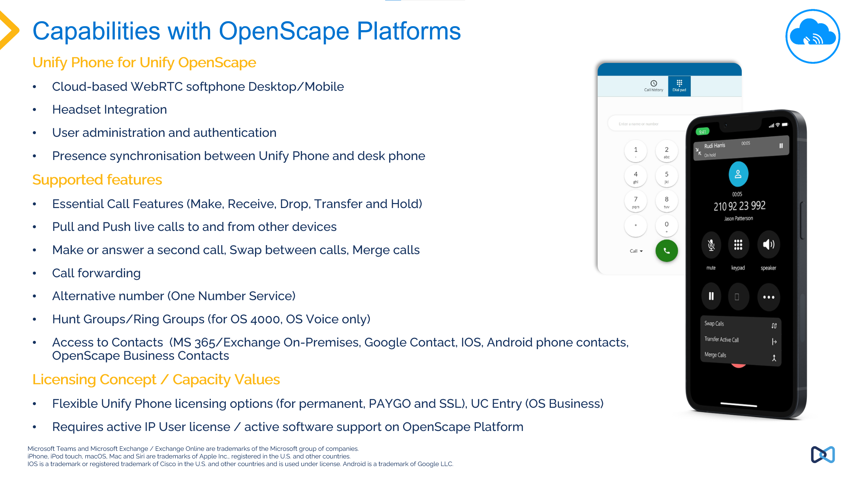
Unify Phone for OpenScape

Unify Phone for OpenScape is combined with OpenScape Voice, OpenScape 4000 and OpenScape Business to provide a cloud-based telephony solution using web and mobile clients deployed to the end users. Customers can provide their existing OpenScape telephony environment to home, mobile and hybrid workers.
Configuration Overview Unify Phone for OpenScape
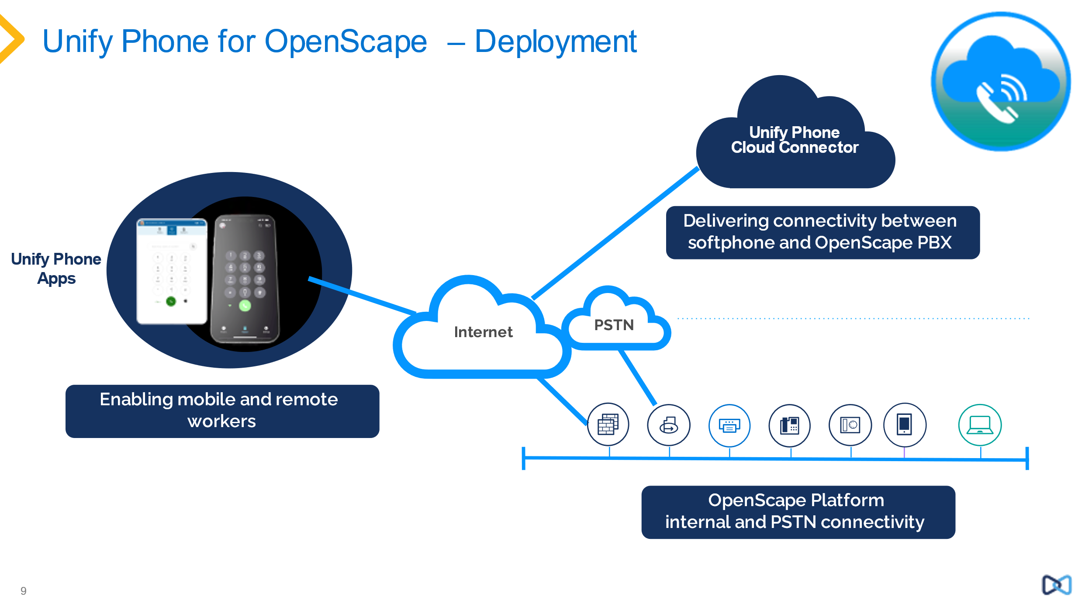
Deployment of Unify Phone for OpenScape
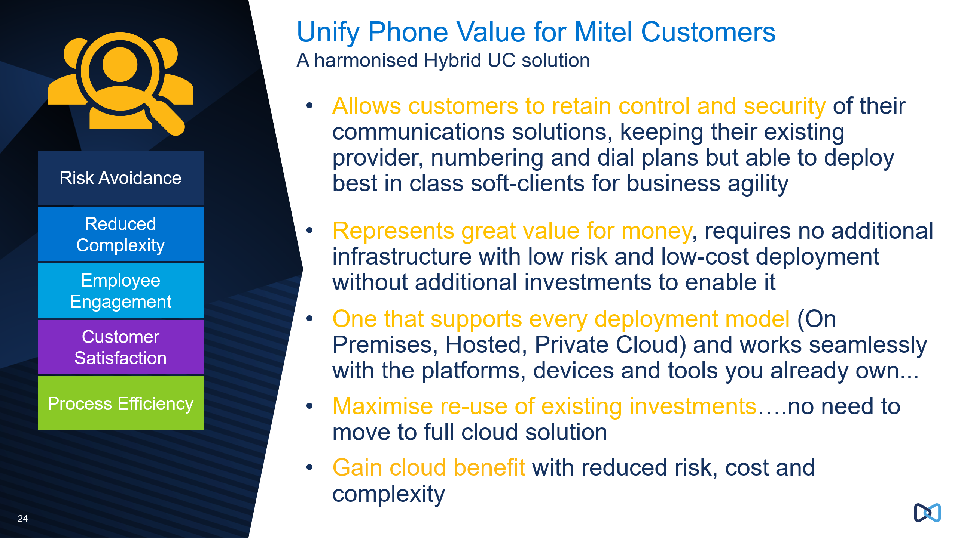
Proposition for Unify Phone for OpenScape

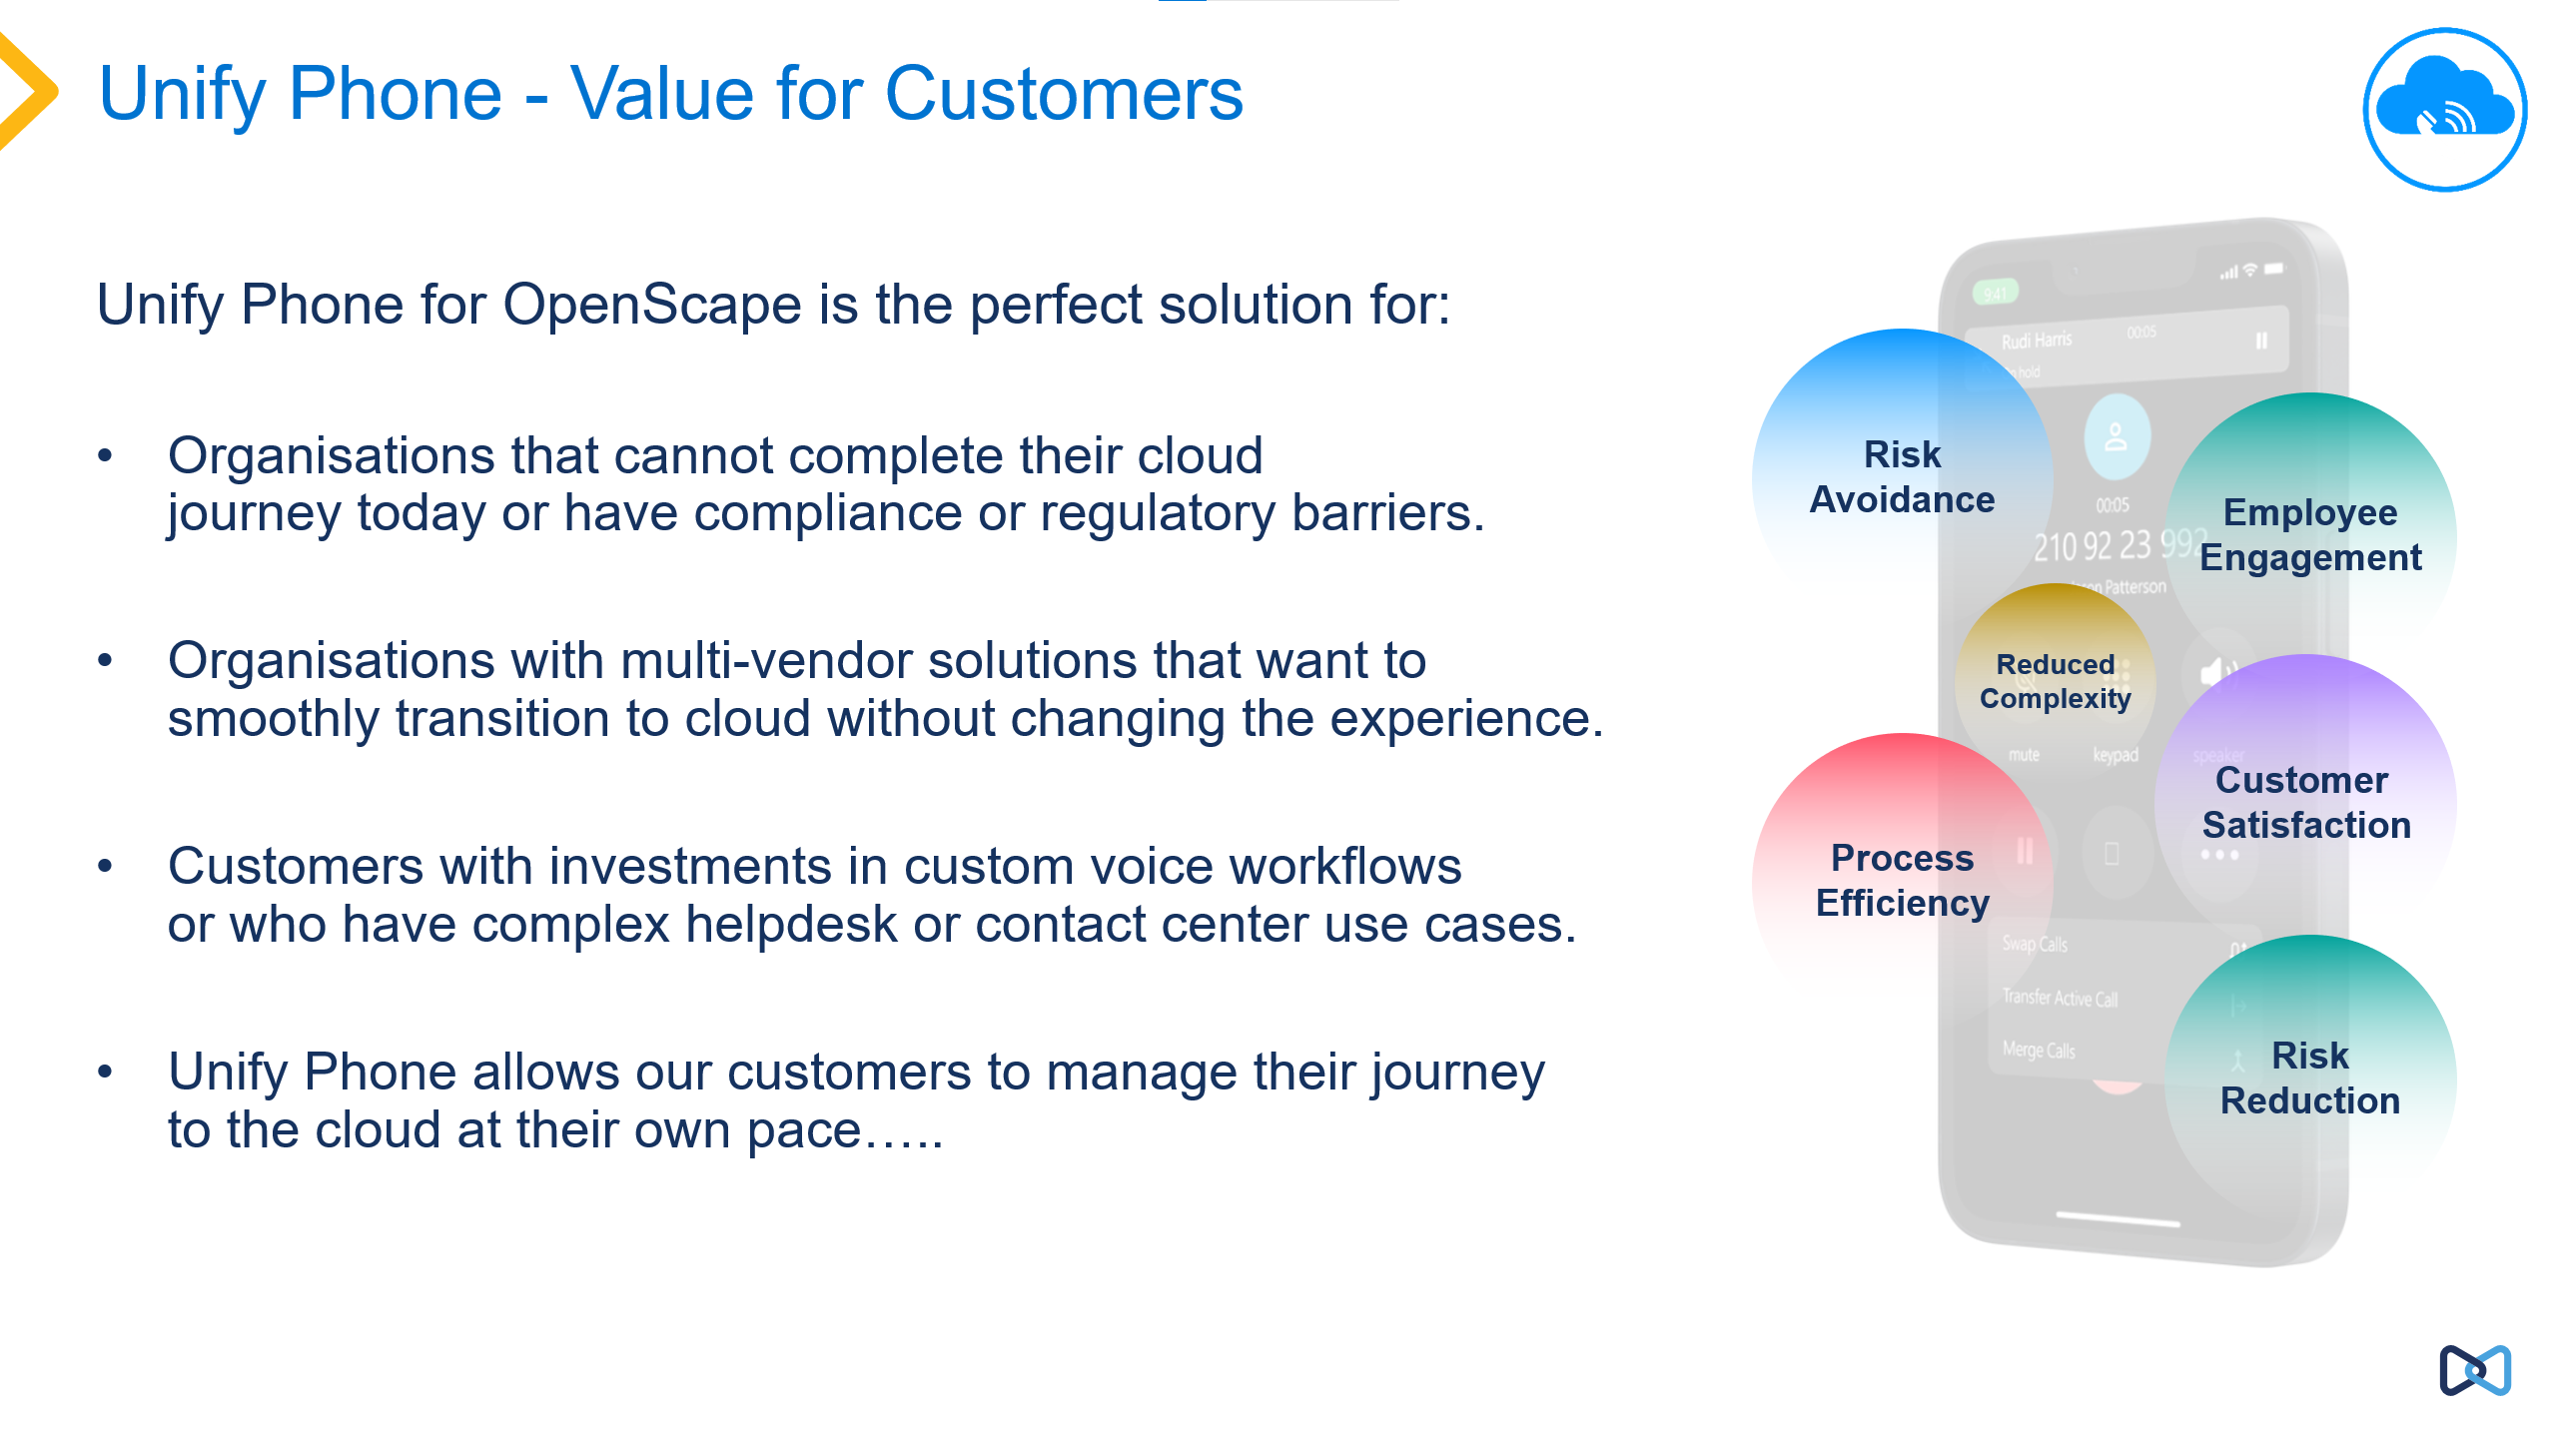
Value of Unify Phone for OpenScape for Customers

Unify Phone for Microsoft Teams
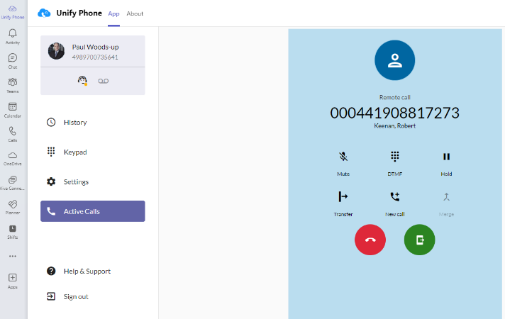
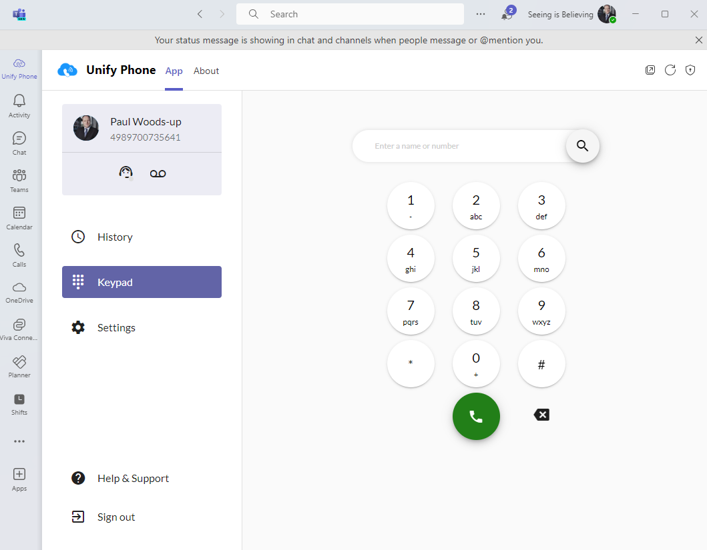

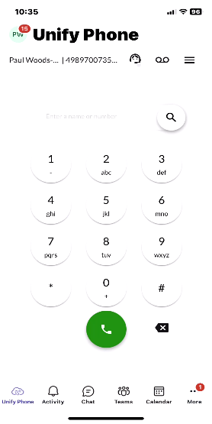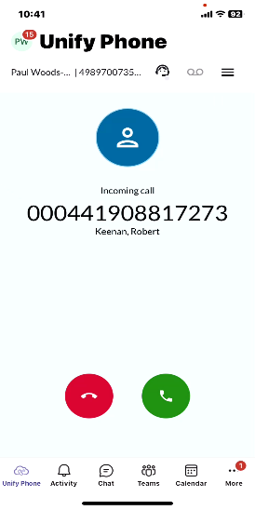

Unify Phone for Microsoft Teams Clients

Unify Phone for Microsoft Teams

Unify Phone for Microsoft Teams provides a plug-in for Microsoft Teams which includes the Unify Phone client, this plug-in is installed in the customers Microsoft environment by this Microsoft Administrator, the plug-in is downloaded from the Microsoft Teams apps store.

The customers end users can then add Unify Phone to their Microsoft Teams client, this inserts the application into their desktop, web and mobile MS Teams clients. Unify Phone can then be used within these clients, to initiate calls, search contacts etc. The Unify Phone embedded application for MS Teams does not require the customer to have Microsoft Teams Phone system licenses or to have an additional SBC, e.g. Audiocodes.

Included in the Unify Phone for Microsoft Teams solution is the presence integration between Microsoft Teams and Unify Phone which is a bi-directional synchronisation.

To deploy Unify Phone for Microsoft then Unify Phone for OpenScape is first deployed. With Unify Phone for OpenScape deployed, then the Unify Phone plug-in for MS Teams is deployed to the Microsoft Teams tenant by the customers Microsoft administrator, who will also carry out the steps to enable the presence synchronisation. Presence synchronisation is enabled for the whole MS Teams tenant and for the whole Unify Phone tenant.

If an end user uninstalls the Unify Phone for MS Teams plug-in, then this presence synchronisation ceases and can be disabled in the Unify Phone client, once disabled then this option is removed from the Unify Phone client. If desired the Unify Phone for MS Teams plug-in can be re-installed which will restore presence synchronization.

It is also possible to mix Unify Phone for OpenScape users (not using the Unify Phone for MS Teams plug-in) and Unify Phone for MS Teams users on the same Unify Phone tenant. Both users are using Unify Phone for OpenScape to provide their telephony. Both can call and be called as they share the same underlying OpenScape platform.
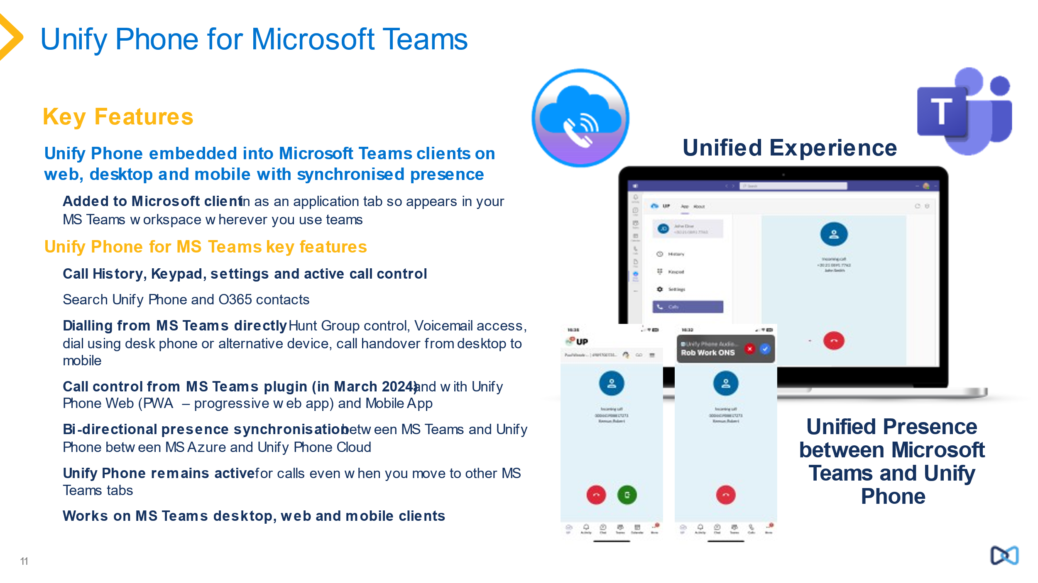
Overview of Unify Phone for Microsoft Teams

Further Unify Phone integrations
Unify Phone also integrates with:
- Microsoft Exchange On-Line
- Microsoft Exchange on Premises
- Google Contacts
- OpenScape Business Contacts
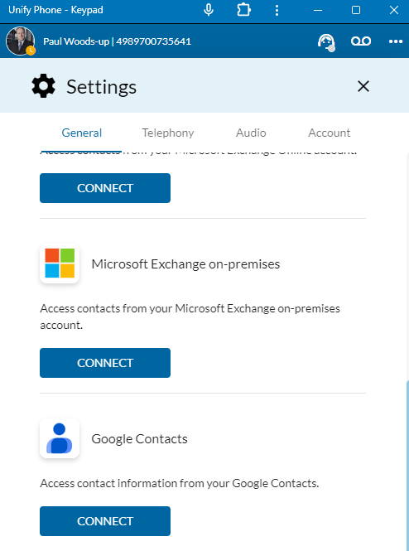
Contacts Integrations Unify Phone

Integration with Apple Car Play - (Android Auto planned in H2 2024)
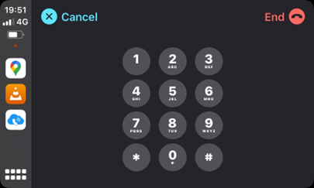

Presence Synchronisation Microsoft Teams and Unify Phone
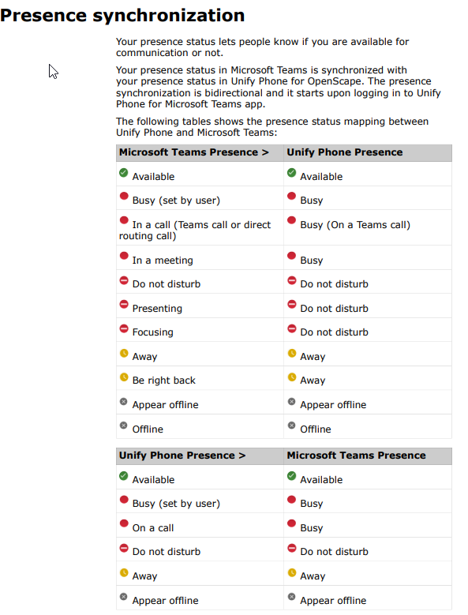
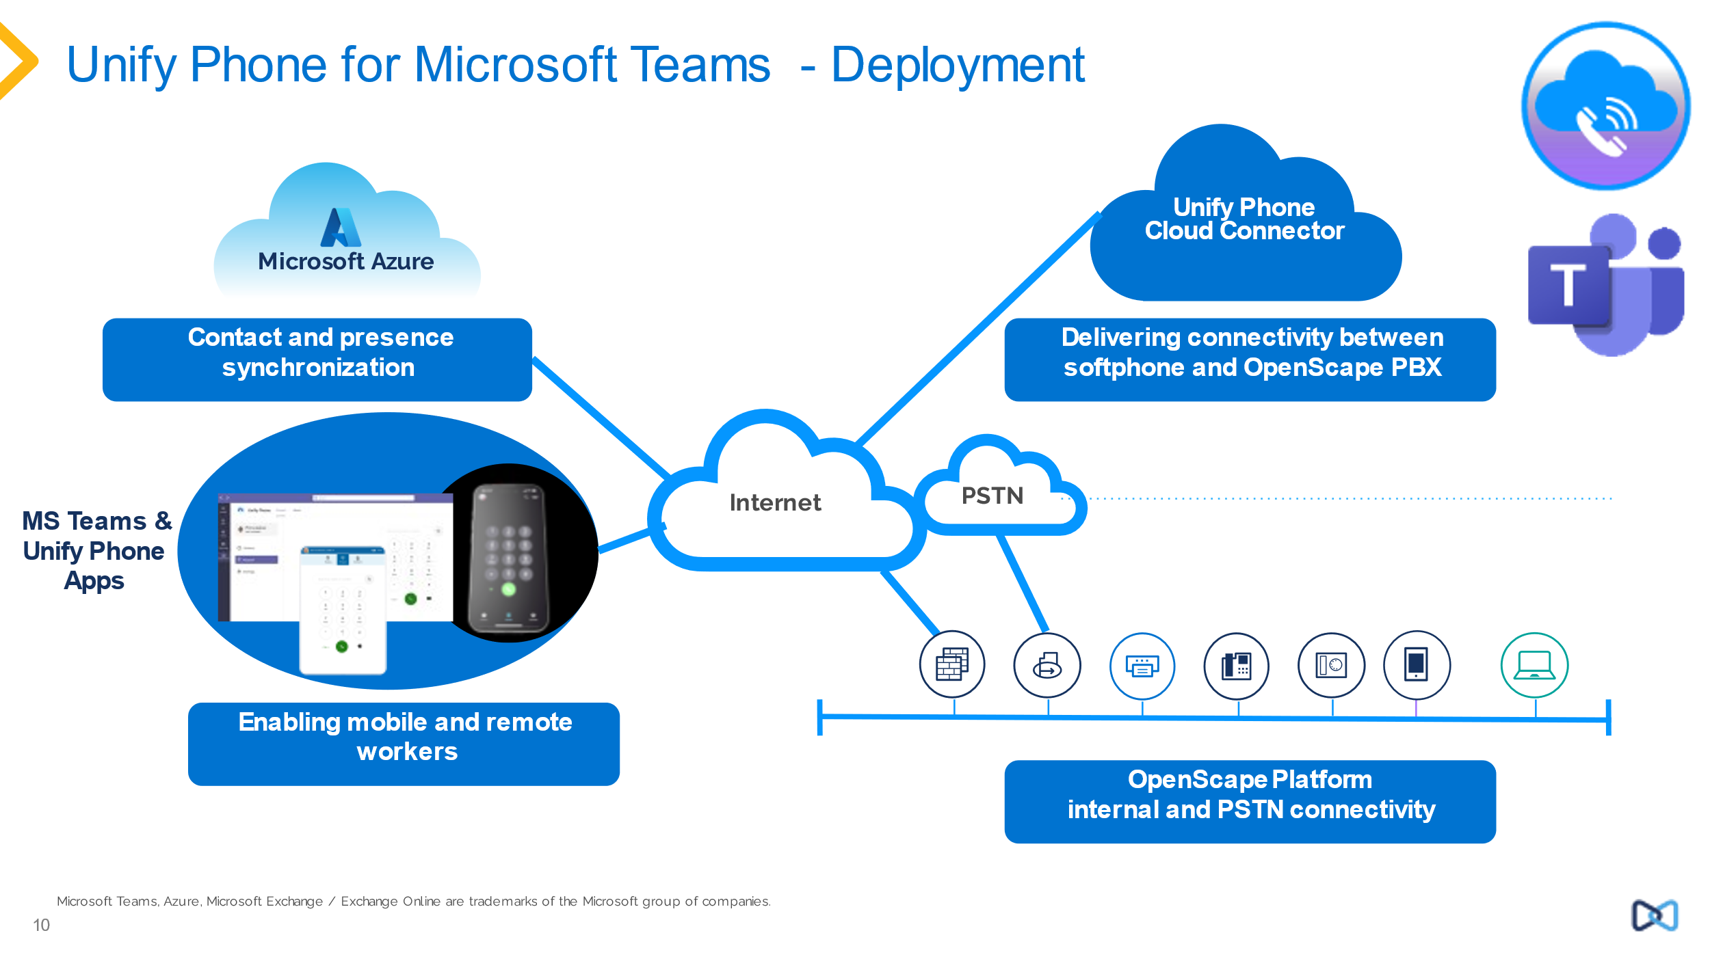
Unify Phone for Microsoft Teams Deployment Scenario

Unify Phone for MS Teams Plug-in from the Microsoft Teams App Store
The Unify Phone MS Teams plug-in can be accessed by customer tenant admins from the Microsoft Store
https://appsource.microsoft.com/en/product/office/WA200006689?tab=Overview
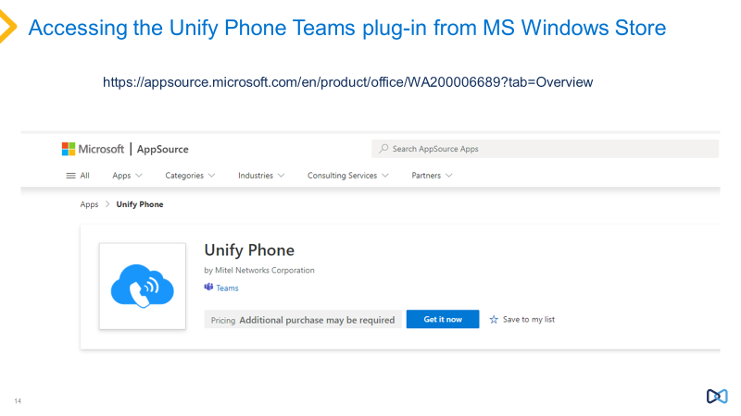

Supported Browsers and Mobile Operating Systems
Browsers Currently supported by Unify Phone
- Google Chrome version 88 or later (supported in the browser, also as a Progressive Web Application)
- Firefox version 88 or later, (progressive web app is not natively supported in Firefox)
- Microsoft Edge version 78 or later (supported in the browser, also as a Progressive Web Application)
- Safari Browser, version 16 or later

As a Mobile Client
- Apple IOS v15 or later
- Google Android v10 or later

Supported Virtual Desktop Infrastructures
Unify Phone web app supports the following Virtual Desktop Infrastructures (VDI):
- Citrix VDI
- VMware Horizon
- Microsoft Terminal Server
Please contact your company administrator for further details if you remotely access company resources through VDI.
There is no specific setting or installation of Unify Phone to support Virtual Desktop necessary.
Unify Phone in a Virtual Desktop environment uses HTML5 redirection, which is application agnostic.
See find more information under:
- https://docs.vmware.com/en/VMware-Horizon/2106/horizon-remote-desktop-features/GUID-E8941DB5-E0AF-4948-86D3-EB2066D4D2E8.html
- https://docs.vmware.com/en/VMware-Horizon/2106/horizon-remote-desktop-features/GUID-6A68ECA4-6B9C-43C5-B437-D39B71005BAD.html
- https://docs.citrix.com/en-us/citrix-virtual-apps-desktops/multimedia/browser-content-redirection.html
- https://learn.microsoft.com/en-us/azure/virtual-desktop/multimedia-redirection?tabs=edge
Note - that sounds/video resources need to be set to shared.
Please also check the web and mobile users guides for Unify Phone for more information and latest updates and supported operating system and browser versions.

Connectivity and Compatible Products
This compatibility applies to Unify Phone for OpenScape (and also applies to use of the Unify Phone for MS Teams plug-in).
The supported platform versions of OpenScape are:
- OpenScape Voice V10 R3
- OpenScape 4000 V10 R1, OpenScape 4000 v11R0
- OpenScape Business V3 R3
- OpenScape SBC v10R3, v11R0

For both OpenScape 4000 and OpenScape Voice OpenScape SBC must also be deployed.
Further release on Mitel voice platforms is planned in 2024-2025.
For latest compability check Unify Phone release notes and the OpenScape Compatibility Matrix.
Currently Unify Phone is not released with OpenScape Contact Center, a further release is planned to use Unify Phone as an end point with OpenScape Contact Center and OpenScape Concierge in a further release of Unify Phone, this is planned for H2 2024. In addition, Unify Phone is not supported with OpenScape UC Applications.
As of Unify Phone v3, Unify Phone is supported with OpenScape Business v3 MyPortal/MyAttendant (not MyAgent) applications, for more details check the OpenScape Business Sales and Administrator documentation.
In addition, there are restrictions documented in the sales and technical information for each of the OpenScape platforms for Unify Phone which should be checked for latest information. Please ensure that these restrictions are checked when proposing Unify Phone as Unify Phone is a remote subscriber to the underlying OpenScape platform, and features, and operation rely on that platform. See OpenScape 4000 IP Solutions Guide Chapter 17 for detailed information on OpenScape 4000.
Note: a valid support contract for the OpenScape platform is required in order to use Unify Phone, so a valid SSP, SWA and maintenance contract is required. This support is enforced in OpenScape Business v3R3 and in OpenScape 4000 v11.

Planned Languages
Unify Phone supports within the Unify Phone clients in the following languages:
- English,
- German
- French
- Spanish
- Italian
- Dutch
- Catalan
- Portuguese (Brazil)
- Basque

Unify Phone supports in the user documentation in the following languages:
- English
- German
- Italian
- French
- Spanish
- Dutch
- Portuguese

Countries
Country | Country Abbreviation | Channel | Document Release | Sales Release | General Availability
Global Partner |  | Global Channel | 16.05.2022 √ | 18.05.2022 √ | 18.05.2022 √
Argentina | AR | Direct Channel | 16.05.2022 √ | 04.03.2024 √ | 04.03.2024 √
Argentina | AR | Indirect Channel | 16.05.2022 √ | 04.03.2024 √ | 04.03.2024 √
Australia | AU | Indirect Channel | 16.05.2022 √ | 18.05.2022 √ | 18.05.2022 √
Austria | AT | CCS Channel | 16.05.2022 √ | 18.05.2022 √ | 18.05.2022 √
Austria | AT | Direct Channel | 16.05.2022 √ | 18.05.2022 √ | 18.05.2022 √
Austria | AT | Indirect Channel | 16.05.2022 √ | 18.05.2022 √ | 18.05.2022 √
Belgium | BE | Direct Channel | 16.05.2022 √ | 18.05.2022 √ | 18.05.2022 √
Belgium | BE | Indirect Channel | 16.05.2022 √ | 18.05.2022 √ | 18.05.2022 √
Brazil | BR | Direct Channel | 16.05.2022 √ | 04.03.2024 √ | 04.03.2024 √
Brazil | BR | Indirect Channel | 16.05.2022 √ | 04.03.2024 √ | 04.03.2024 √
Bulgaria | BG | Indirect Channel | 16.05.2022 √ | 18.04.2023 √ | 18.04.2023 √
Canada | CA | Indirect Channel | 12.08.2024 √ | 02.09.2024 | 02.09.2024
Chile | CL | Direct Channel | 16.05.2022 √ | 04.03.2024 √ | 04.03.2024 √
Chile | CL | Indirect Channel | 16.05.2022 √ | 04.03.2024 √ | 04.03.2024 √
Colombia | CO | Direct Channel | 16.05.2022 √ | 04.03.2024 √ | 04.03.2024 √
Colombia | CO | Indirect Channel | 16.05.2022 √ | 04.03.2024 √ | 04.03.2024 √
Country | Country Abbreviation | Channel | Document Release | Sales Release | General Availability
Costa Rica | CR | Indirect Channel | 16.05.2022 √ | 04.03.2024 √ | 04.03.2024 √
Croatia | HR | Indirect Channel | 16.05.2022 √ | 18.04.2023 √ | 18.04.2023 √
Cyprus | CY | Indirect Channel | 16.05.2022 √ | 18.04.2023 √ | 18.04.2023 √
Czech Republic | CZ | Indirect Channel | 16.05.2022 √ | 18.04.2023 √ | 18.04.2023 √
Denmark | DK | Indirect Channel | 16.05.2022 √ | 18.04.2023 √ | 18.04.2023 √
Ecuador | EC | Indirect Channel | 16.05.2022 √ | 04.03.2024 √ | 04.03.2024 √
El Salvador | SV | Indirect Channel | 16.05.2022 √ | 04.03.2024 √ | 04.03.2024 √
Estonia | EE | Indirect Channel | 16.05.2022 √ | 18.04.2023 √ | 18.04.2023 √
Finland | FI | Direct Channel | 25.01.2024 √
Finland | FI | Indirect Channel | 16.05.2022 √ | 18.05.2022 √ | 18.05.2022 √
France | FR | CCS Channel | 16.05.2022 √ | 18.05.2022 √ | 18.05.2022 √
France | FR | Indirect Channel | 16.05.2022 √ | 18.05.2022 √ | 18.05.2022 √
Germany | DE | CCS Channel | 16.05.2022 √ | 18.05.2022 √ | 18.05.2022 √
Germany | DE | Direct Channel | 16.05.2022 √ | 18.05.2022 √ | 18.05.2022 √
Germany | DE | Indirect Channel | 16.05.2022 √ | 18.05.2022 √ | 18.05.2022 √
Greece | GR | Indirect Channel | 16.05.2022 √ | 18.04.2023 √ | 18.04.2023 √
Guatemala | GT | Indirect Channel | 16.05.2022 √ | 04.03.2024 √ | 04.03.2024 √
Honduras | HN | Indirect Channel | 16.05.2022 √ | 04.03.2024 √ | 04.03.2024 √
Country | Country Abbreviation | Channel | Document Release | Sales Release | General Availability
Hungary | HU | Indirect Channel | 16.05.2022 √ | 18.04.2023 √ | 18.04.2023 √
India | IN | Direct Channel | 12.08.2024 √
India | IN | Indirect Channel | 12.08.2024 √ | 02.09.2024 | 02.09.2024
Ireland | IE | Indirect Channel | 16.05.2022 √ | 18.05.2022 √ | 18.05.2022 √
Italy | IT | Direct Channel | 16.05.2022 √ | 18.05.2022 √ | 18.05.2022 √
Italy | IT | Indirect Channel | 16.05.2022 √ | 18.05.2022 √ | 18.05.2022 √
Latvia | LV | Indirect Channel | 16.05.2022 √ | 18.04.2023 √ | 18.04.2023 √
Lithuania | LT | Indirect Channel | 16.05.2022 √ | 18.04.2023 √ | 18.04.2023 √
Luxembourg | LU | Direct Channel | 25.01.2024 √
Luxembourg | LU | Indirect Channel | 16.05.2022 √ | 18.04.2023 √ | 18.04.2023 √
Malta | MT | Indirect Channel | 16.05.2022 √ | 18.04.2023 √ | 18.04.2023 √
Mexico | MX | Direct Channel | 16.05.2022 √ | 04.03.2024 √ | 04.03.2024 √
Mexico | MX | Indirect Channel | 16.05.2022 √ | 04.03.2024 √ | 04.03.2024 √
Namibia | NA | Indirect Channel | 12.08.2024 √ | 02.09.2024 | 02.09.2024
Netherlands | NL | Direct Channel | 16.05.2022 √ | 18.05.2022 √ | 18.05.2022 √
Netherlands | NL | Indirect Channel | 16.05.2022 √ | 18.05.2022 √ | 18.05.2022 √
New Zealand | NZ | Indirect Channel | 16.05.2022 √ | 04.03.2024 √ | 04.03.2024 √
Nicaragua | NI | Indirect Channel | 16.05.2022 √ | 04.03.2024 √ | 04.03.2024 √
Country | Country Abbreviation | Channel | Document Release | Sales Release | General Availability
Norway | NO | Indirect Channel | 16.05.2022 √ | 18.04.2023 √ | 18.04.2023 √
Panama | PA | Indirect Channel | 16.05.2022 √ | 04.03.2024 √ | 04.03.2024 √
Paraguay | PY | Indirect Channel | 16.05.2022 √ | 04.03.2024 √ | 04.03.2024 √
Peru | PE | Indirect Channel | 16.05.2022 √ | 04.03.2024 √ | 04.03.2024 √
Poland | PL | Direct Channel | 25.01.2024 √
Poland | PL | Indirect Channel | 16.05.2022 √ | 18.04.2023 √ | 18.04.2023 √
Portugal | PT | Indirect Channel | 16.05.2022 √ | 18.05.2022 √ | 18.05.2022 √
Romania | RO | Indirect Channel | 16.05.2022 √ | 18.04.2023 √ | 18.04.2023 √
Singapore | SG | Indirect Channel | 12.08.2024 √ | 02.09.2024 | 02.09.2024
Slovakia | SK | Indirect Channel | 16.05.2022 √ | 18.04.2023 √ | 18.04.2023 √
Slovenia | SI | Indirect Channel | 16.05.2022 √ | 18.04.2023 √ | 18.04.2023 √
South Africa | ZA | Indirect Channel | 12.08.2024 √ | 02.09.2024 | 02.09.2024
Spain | ES | Direct Channel | 16.05.2022 √ | 18.05.2022 √ | 18.05.2022 √
Spain | ES | Indirect Channel | 16.05.2022 √ | 18.05.2022 √ | 18.05.2022 √
Sweden | SE | Direct Channel | 25.01.2024 √
Sweden | SE | Indirect Channel | 16.05.2022 √ | 18.04.2023 √ | 18.04.2023 √
Switzerland | CH | Indirect Channel | 16.05.2022 √ | 02.01.2023 √ | 02.01.2023 √
United Kingdom | GB | CCS Channel | 16.05.2022 √ | 18.05.2022 √ | 18.05.2022 √
Country | Country Abbreviation | Channel | Document Release | Sales Release | General Availability
United Kingdom | GB | Direct Channel | 16.05.2022 √ | 18.05.2022 √ | 18.05.2022 √
United Kingdom | GB | Indirect Channel | 16.05.2022 √ | 18.05.2022 √ | 18.05.2022 √
Uruguay | UY | Indirect Channel | 16.05.2022 √ | 04.03.2024 √ | 04.03.2024 √
USA | US | CCS Channel | 16.05.2022 √ | 18.05.2022 √ | 18.05.2022 √
USA | US | Direct Channel | 16.05.2022 √ | 02.01.2023 √ | 02.01.2023 √
USA | US | Indirect Channel | 16.05.2022 √ | 18.05.2022 √ | 18.05.2022 √
Vietnam | VN | Indirect Channel | 12.08.2024 √ | 02.09.2024 | 02.09.2024
Further country releases are planned for 2024.
If you have an opportunity in country not listed here, please contact Unify Phone product management.

Description of Features
Features of Unify Phone
General Features which apply to both Unify Phone for OpenScape and Unify Phone for Microsoft Teams
Unify Phone allows users via their Unify Phone web and mobile clients to access the features below:
- Make call, Answer, decline or drop a call
- Send DTMF commands in a call
- Hold and retrieve, Mute/ Unmute, Transfer call
- Pull call from other Unify Phone clients or desk phone, Push call to desk phone
- Push call to alternative number
- Make or answer a second call, Swap calls (alternate)
- Merge two calls into a conference
- Call forwarding, Alternative number (One Number Service)
- Call routing, Voicemail
- Remote call control of desk phone (Computer Telephony Integration - CTI): hold and retrieve, end call, swap calls, transfer, merge into conference
- Access to contacts via MS Office 365, Exchange On-Premises, Google, Mobile Contacts on IOS and Android
- Presence Management (presence synchronised when using Unify Phone MS Teams plug-in)
- Headset integration (Jabra/Plantronics)
- Hunt-Group support OS Voice v10, OS 4000 v11 (direct selection of hunt groups in the Unify Phone Client)

Note – specific features may vary in availability and operation depending on the OpenScape platform. More information is provided in the User Guides for Unify Phone for the relevant platforms which also detailed specific features of Unify Phone for OpenScape.
For more details on the tenant administration features then please check the Tenant Administration Guide and for specific user features the user guides for Unify Phone for OpenScape Business and OpenScape 4000/Voice web and mobile versions.
For Unify Phone for Microsoft Teams, the plug-in in Teams does not contain a soft-client, to enable voice calls then Unify Phone for OpenScape is used in either web or Progressive Web App (PWA) format. The call controls for Unify Phone are embedded in the MS Teams plug-in for easier control of calls.
Calls started on Unify Phone for MS Teams plug-in will if the call is targeted to use Unify Phone for OpenScape initiate the call via the Unify Phone for OpenScape client, if they user targets the call at his OpenScape Desk Phone or an alternative device then this call can be controlled from the Unify Phone for MS Teams plug-in.
For full details see the user guides for Unify Phone for OpenScape and Unify Phone for Microsoft Team which describes the detailed features relating to Unify Phone for MS Teams plug-in.

Key Aspects of the Unify Phone Solution
- You can combine multiple OpenScape different Platforms onto the same Unify Phone tenant e.g. you can mix OpenScape Voice, OpenScape 4000 and OpenScape Business on the same Unify Phone Tenant.
- You cannot use the same OpenScape Platform on more than one Unify Phone tenant. We plan a new solution called Unify Management Center to allow this capability in H2 2024.
- Unify Phone checks on login if the user is using Unify Phone for OpenScape.
- Please also check the information relevant to each platform for any restrictions to use of Unify Phone, this information in our standard Portfolio pages.
- To deploy Unify Phone for Microsoft Teams, the Unify Phone for OpenScape is deployed initially, Unify Phone for Microsoft Teams is a plug-in for Microsoft Teams but relies on the use of the Unify Phone for OpenScape browser or progressive web app.
- The login to Unify Phone for MS Teams is the user’s login to Unify Phone for OpenScape.
- The Unify Phone for MS Teams plug-in is obtained from the Microsoft App store for Teams

Onboarding for Unify Phone for OpenScape
- Unify Phone for OpenScape is wholly provided by Unify.
- All users are provisioned using Unify Phone and the associated OpenScape platform.
- A new tenant is onboarded using a tenant invite process, a customer or partner can request the invite to a new Unify Phone tenant (the tenant invite process is documented in a separate document in the Unify Phone portfolio pages.
- For direct customers this is a request from service or professional services to a provided email address for requesting new tenants to our Cloud Operations Team using a standard form.
- For indirect customers and partners this is done by their nominated distributor who will request the tenant on their behalf using the same process
- The tenant invites will be sent within 72 business hours, to the nominated email address for the tenant admin, the nominated tenant admin then activates that tenant, signs and click the terms and conditions of use and is then provisioned as the tenant admin of that Unify Phone tenant.
- The initial tenant admin can add other tenant admins e.g. their supporting partner or distribution partner or others in their organisation.
- Users can then be added to Unify Phone as detailed in the Administration guide for Unify Phone which can be found in the Portfolio page for Unify Phone.
- For further information see the Unify Phone Tenant Administration Guide

Onboarding for Unify Phone for Microsoft Teams
- In general, the onboarding process for Unify Phone for OpenScape is followed initially.
- A Unify Phone for OpenScape Tenant is enabled, users are enabled with Unify Phone for OpenScape login credentials (username/password or SSO).
- To add Unify Phone for MS Teams plug-in then the customer’s tenant administrator for Microsoft Teams will add the Unify Phone for MS Teams plug-in and also enable presence synchronisation for Unify Phone (the plug-in is obtained from the MS Teams app store)
- The customers’ users will then add the Unify Phone for MS Teams plug-in to the Microsoft Teams account, simply by searching and adding the application
- Once customers’ users start the plug-in they will login using their Unify Phone for OpenScape credentials to enable and start the Unify Phone plug-in, they should only need to do this once. This works on both MS Teams web and desktop client (also note we are working to fully support the new MS Teams v2 clients)
- Unify Phone will also work on the customers’ users MS Teams mobile client, on the customers’ mobile device they will also use the Unify Phone mobile application in conjunction with the MS Teams mobile application.
- For further information see the Unify Phone Tenant Administration Guide and the Unify Phone for MS Teams User Guide

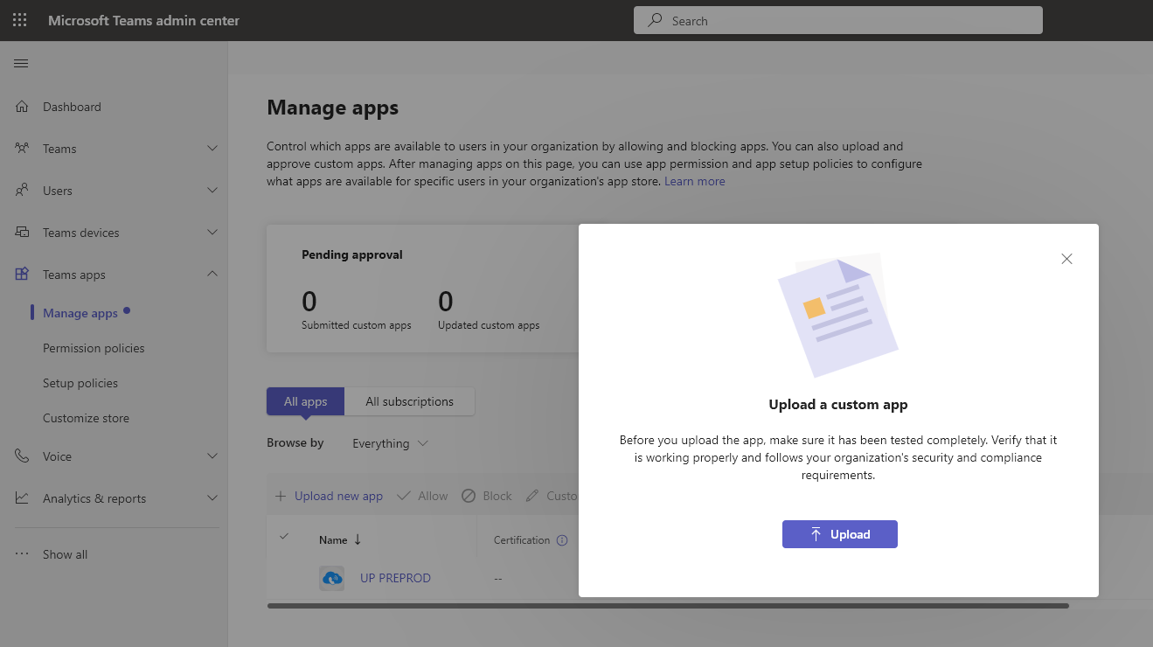
Uploading Unify Phone for MS Teams plug-in to Microsoft Tenant as a customer app.
Link to MS Teams Store for Unify Phone for MS Teams plug-in
https://appsource.microsoft.com/en/product/office/WA200006689?tab=Overview
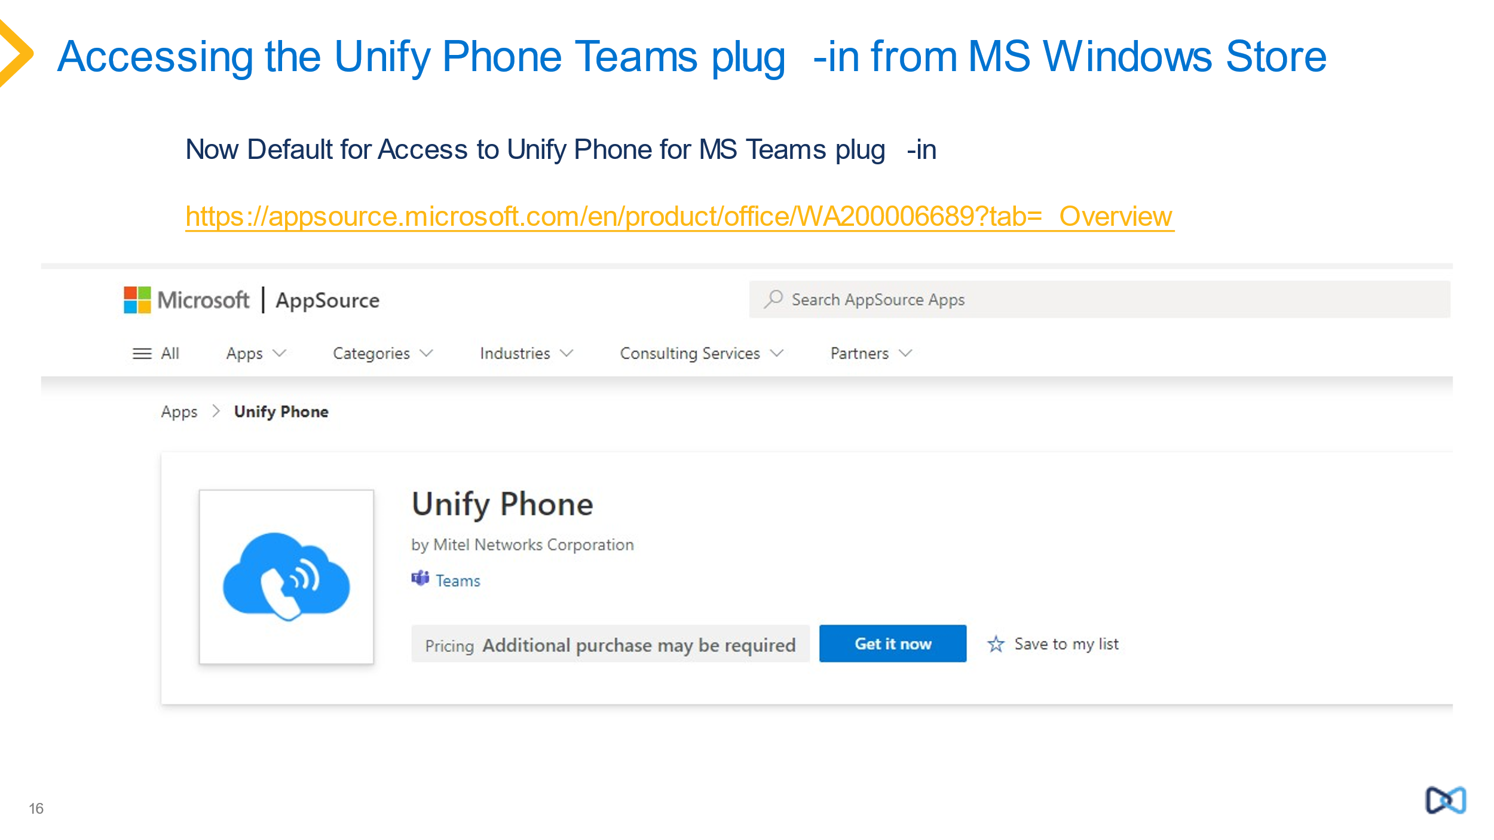
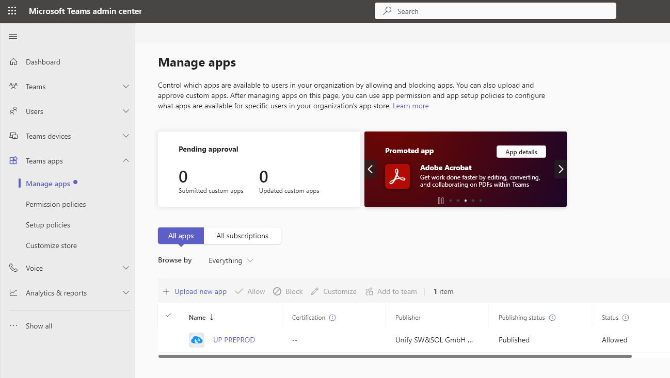
Unify Phone for MS Teams now added as a customer app to the MS Teams tenant.

Customer Benefits
- Unify Phone provides a new way to deliver easy to use telephony from the cloud based on customers’ existing OpenScape platforms.
- Unify Phone allows customers to retain control and security of their communications, keep their existing provider, numbering and dial plan in a friendly and familiar way.
- Unify Phone represents great value for money, requires no additional infrastructure, avoids added complexity or dependency on third-party professional services.
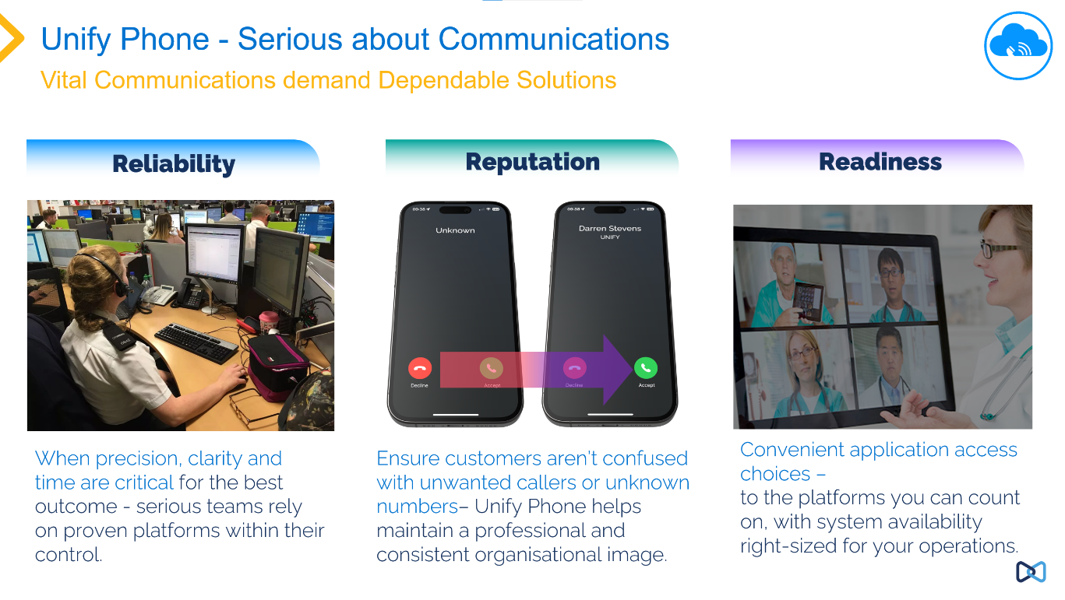
- Unify Phone supports every deployment model (On Premise, Hybrid, Cloud) and works seamlessly with the platforms, devices and tools that customers already own.
Why Unify Phone is important for Customers

Unique Selling Proposition (USP)
We know the market for communications and collaboration is mixed, customers have requirements for different solutions, pure cloud to premise solutions. Many customers require hybrid solutions which are transitional to a migration to cloud or where customers require a mix of cloud, hosted and premise and look for hybrid solutions to cope with their requirements and where customers have a myriad of different business needs and types of workers.
We see this where there are frontline workers who require highly reliable and robust communications. With this in mind Unify has devised a range of solutions to meet these requirements.
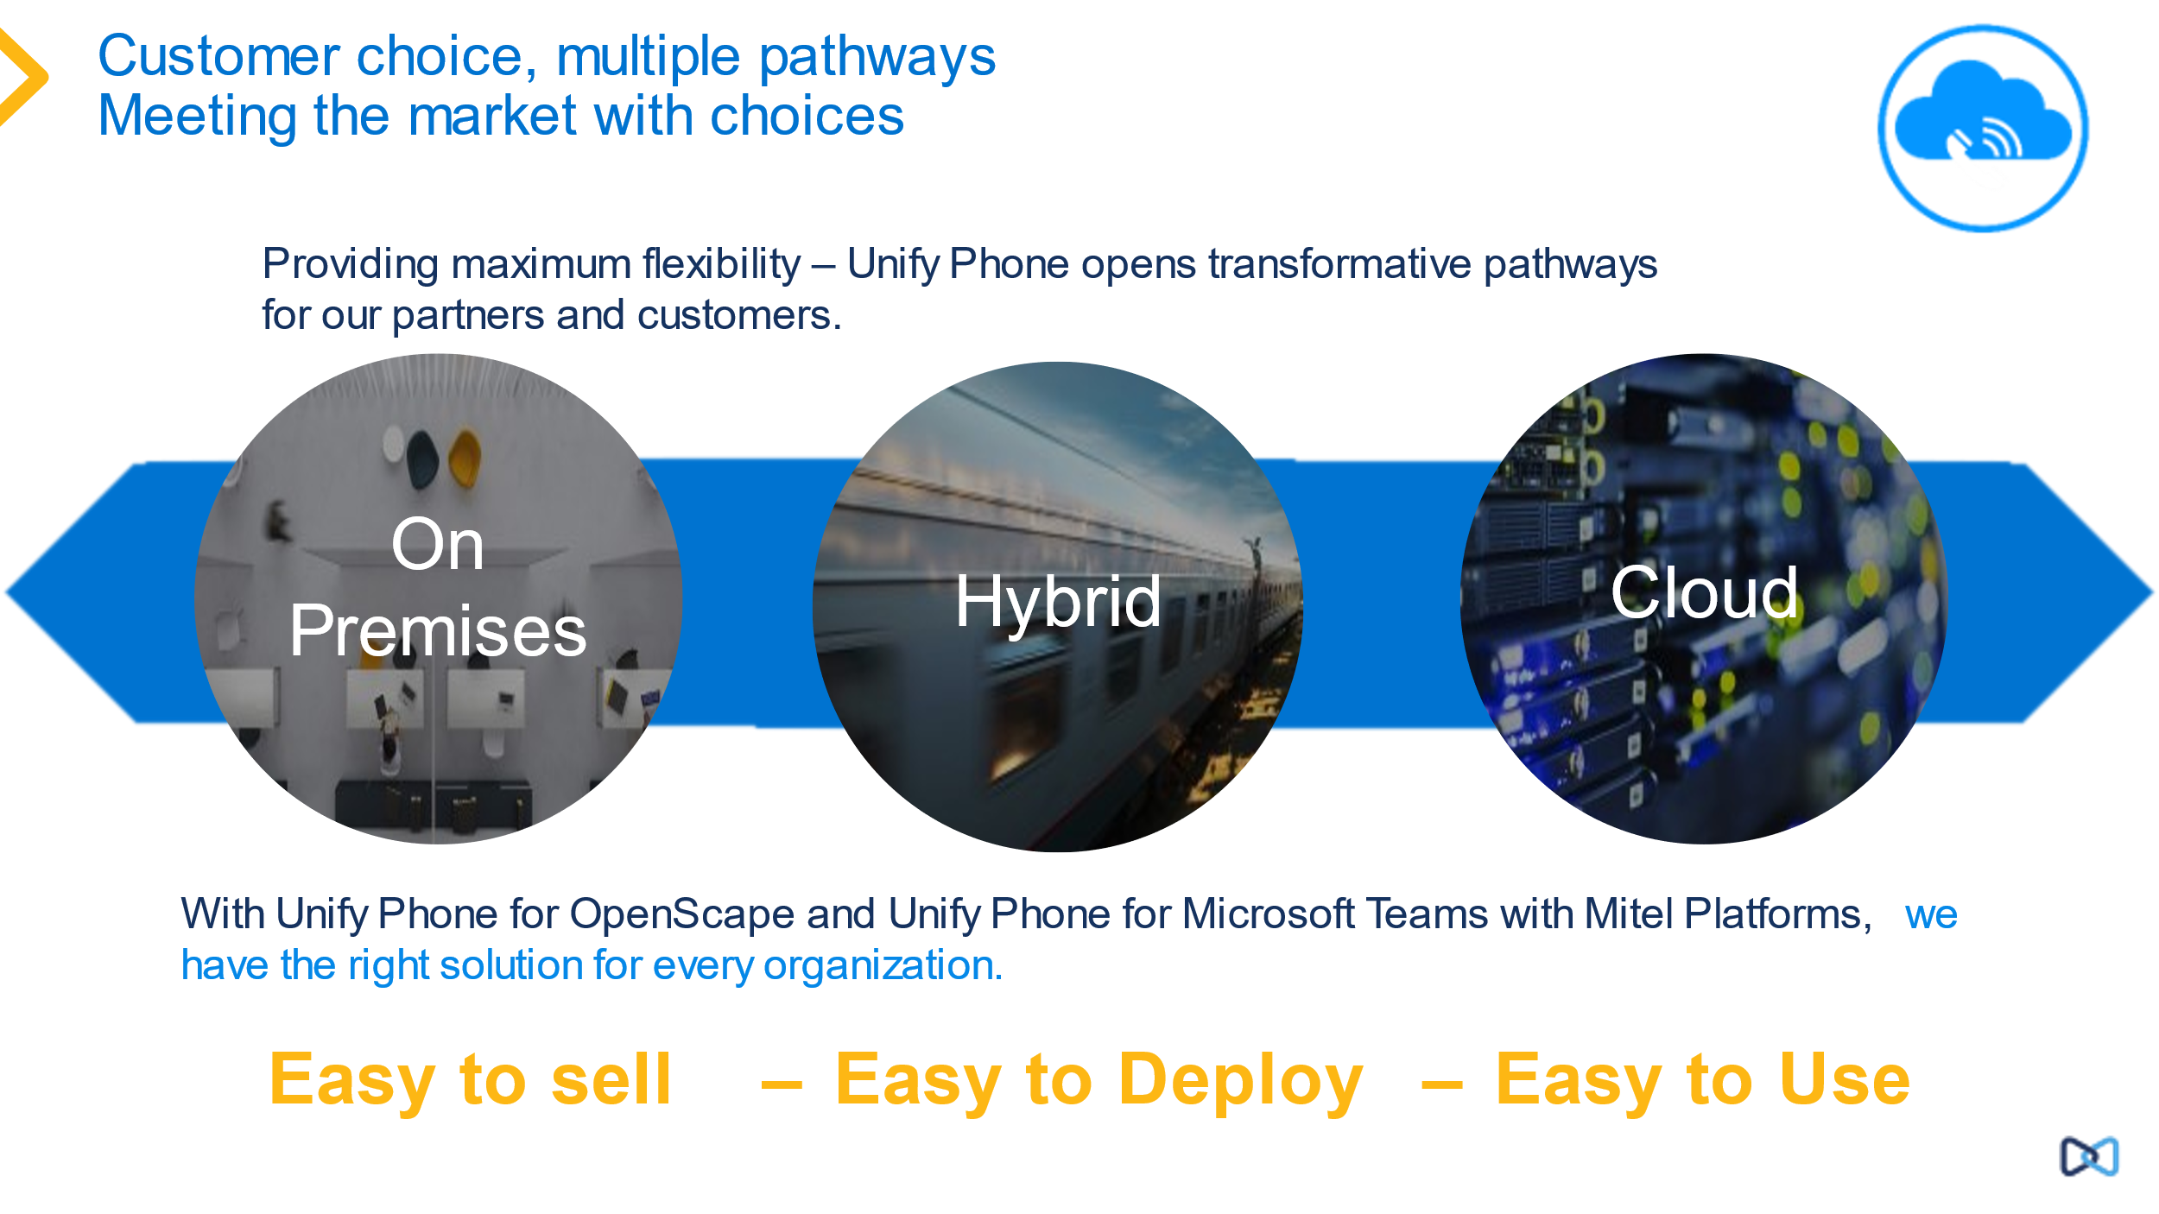
Unify Offers customer choice of solutions
Unify provides multiple migration paths depending on customer migration requirements. Unify Phone for OpenScape provides a hybrid migration option for customers who want to combine their existing OpenScape solution with a cloud solution.
With Unify Phone we can offer customers a unique integration solution from Unify which combines cloud and premise into one end to end solution from Unify supporting hybrid working scenarios and the ease of a cloud based easy to use telephony client.

Implementation and Networking Scenarios

Configuration Overview
Unify Phone for OpenScape
Below we show the general overview of the components and clients of the Unify Phone for OpenScape Solution. The OpenScape Platform is connected to the Unify Phone Service (as before). The administrator of users is done using the Unify Phone Cloud service combined with the OpenScape platform. The users are authenticated using the Unify Phone cloud service.
NGTC is the former name, Next Generation Telephony Connector for Unify Phone.


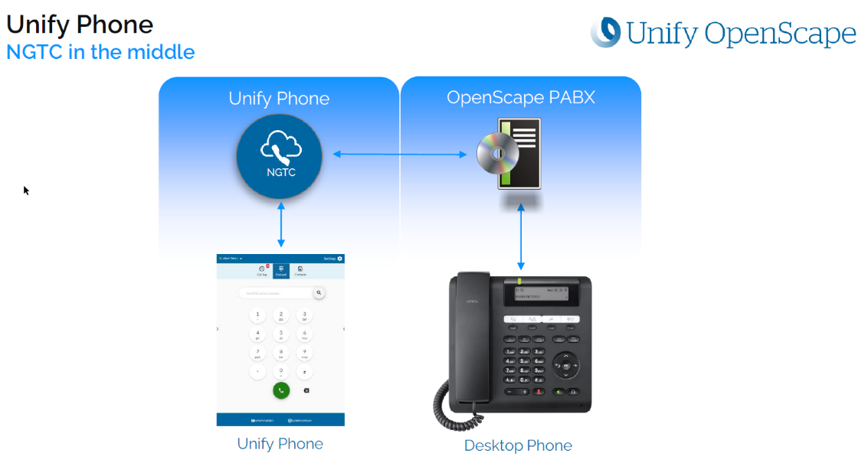
Unify Phone for OpenScape General Overview
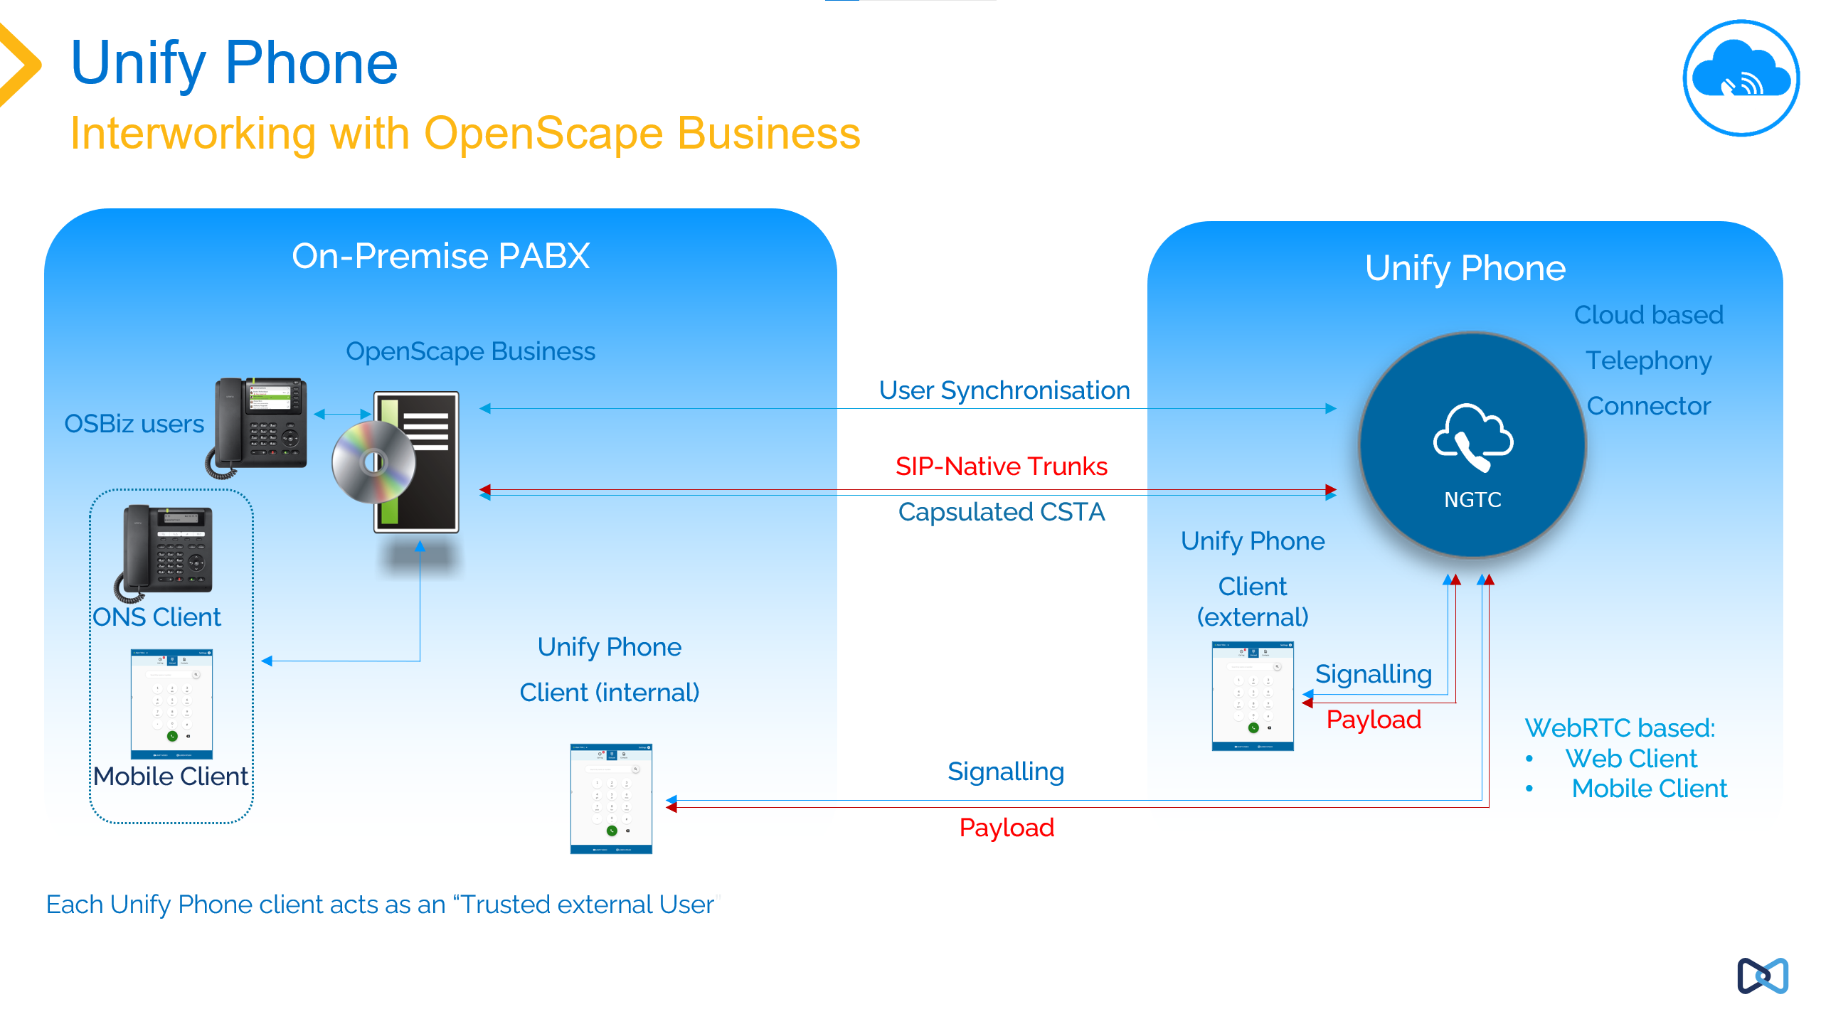
Unify Phone for OpenScape for OpenScape Business

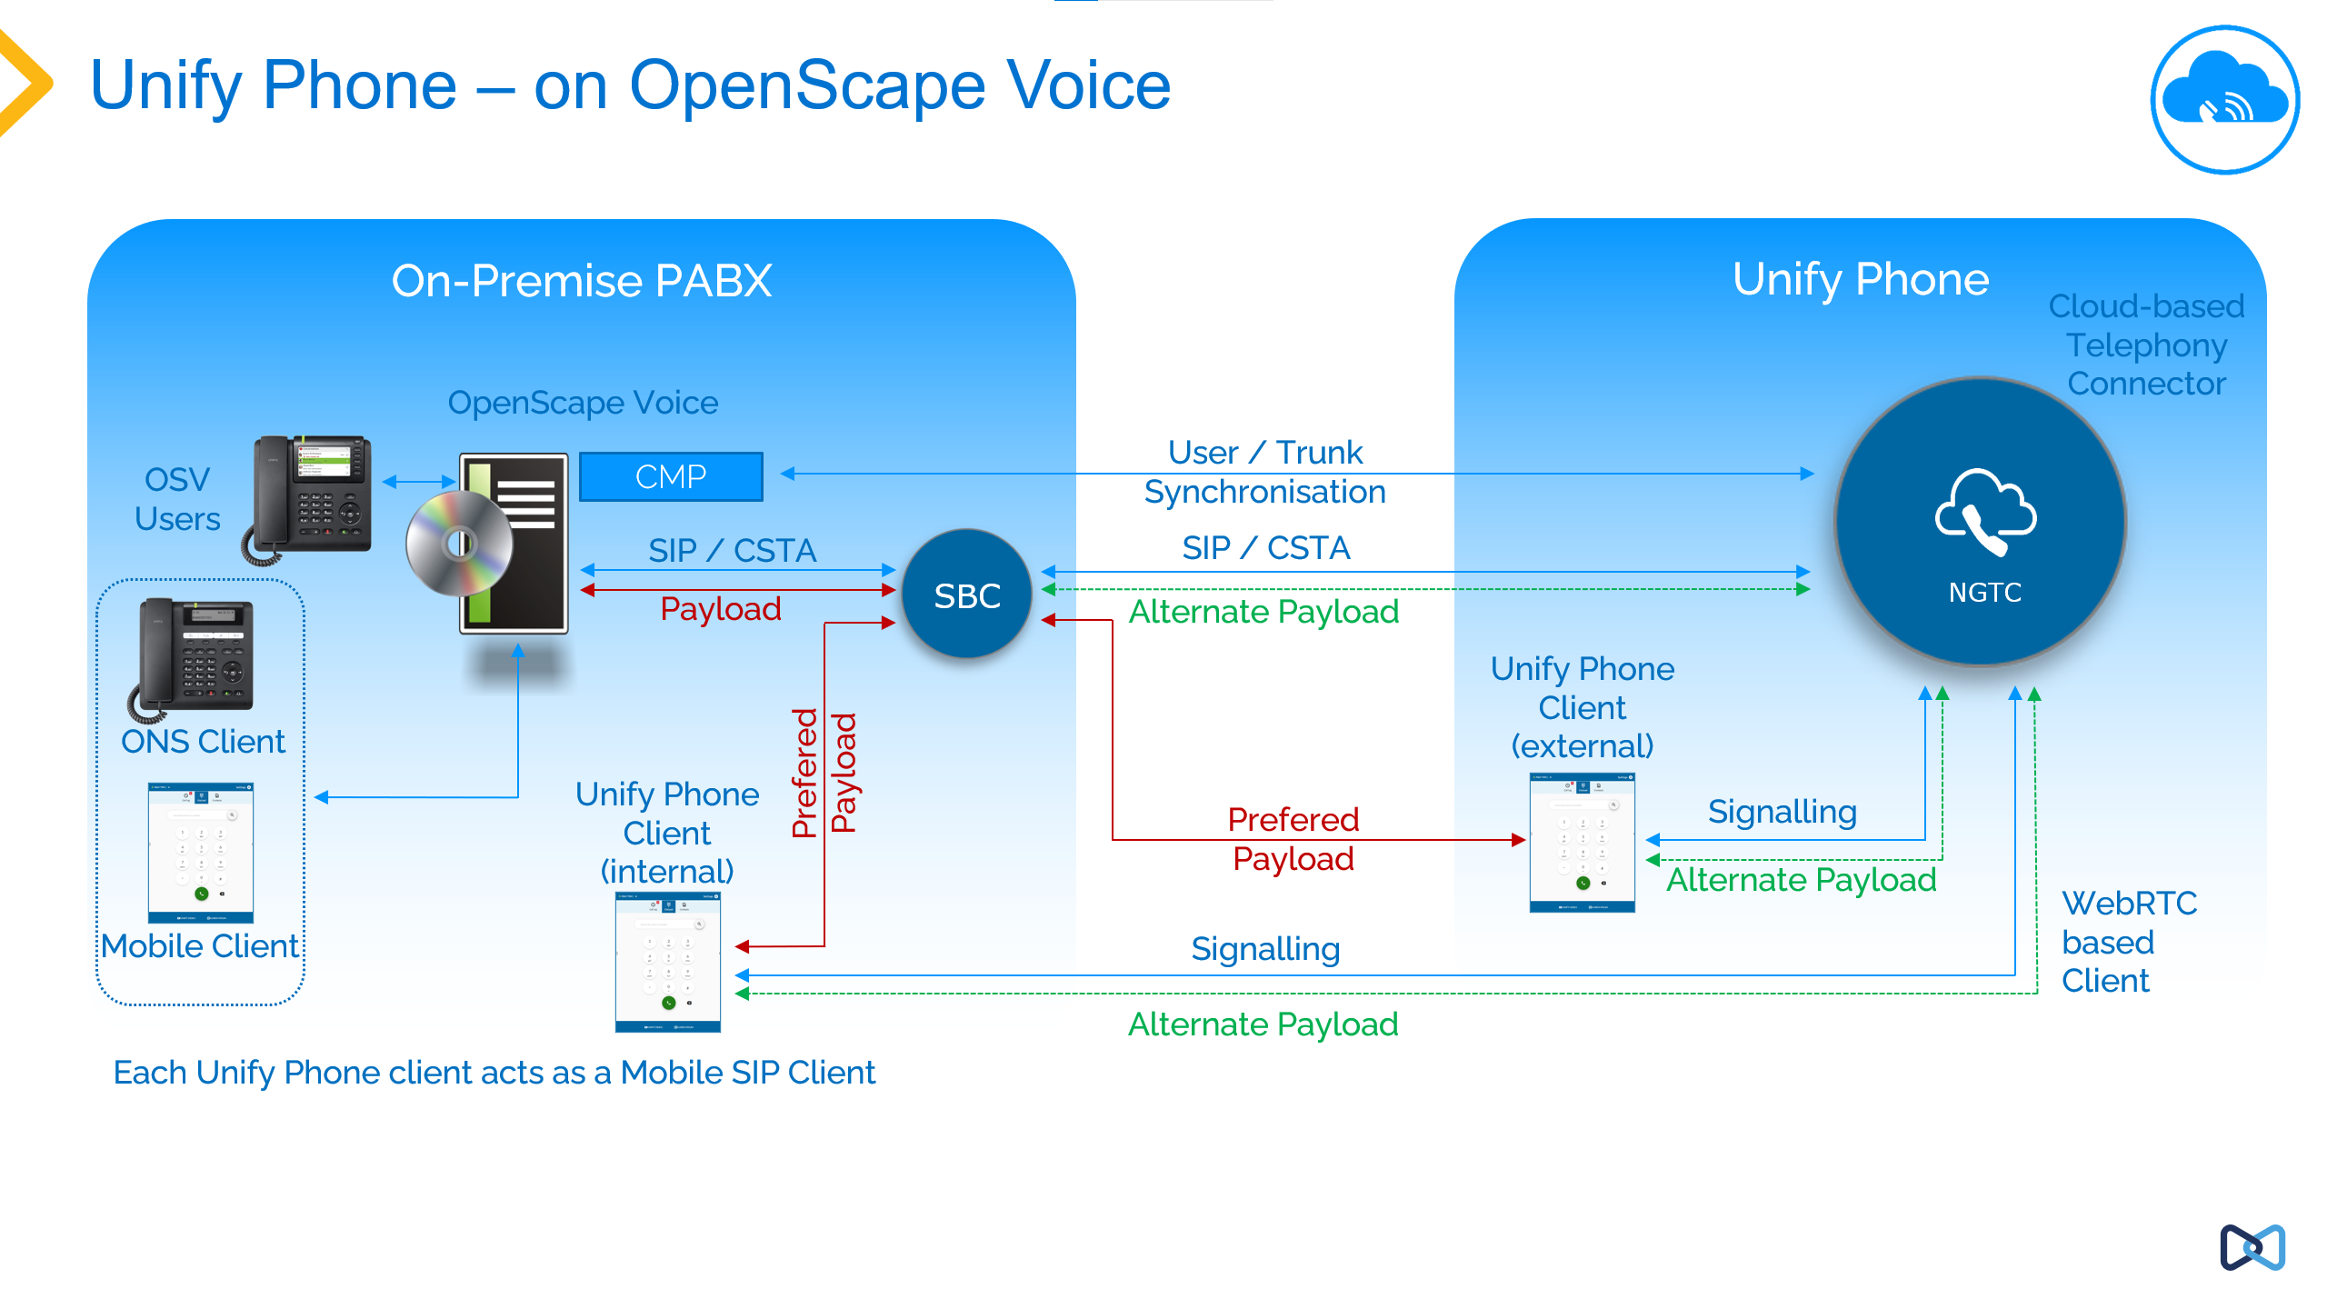Unify Phone for OpenScape for OpenScape Voice

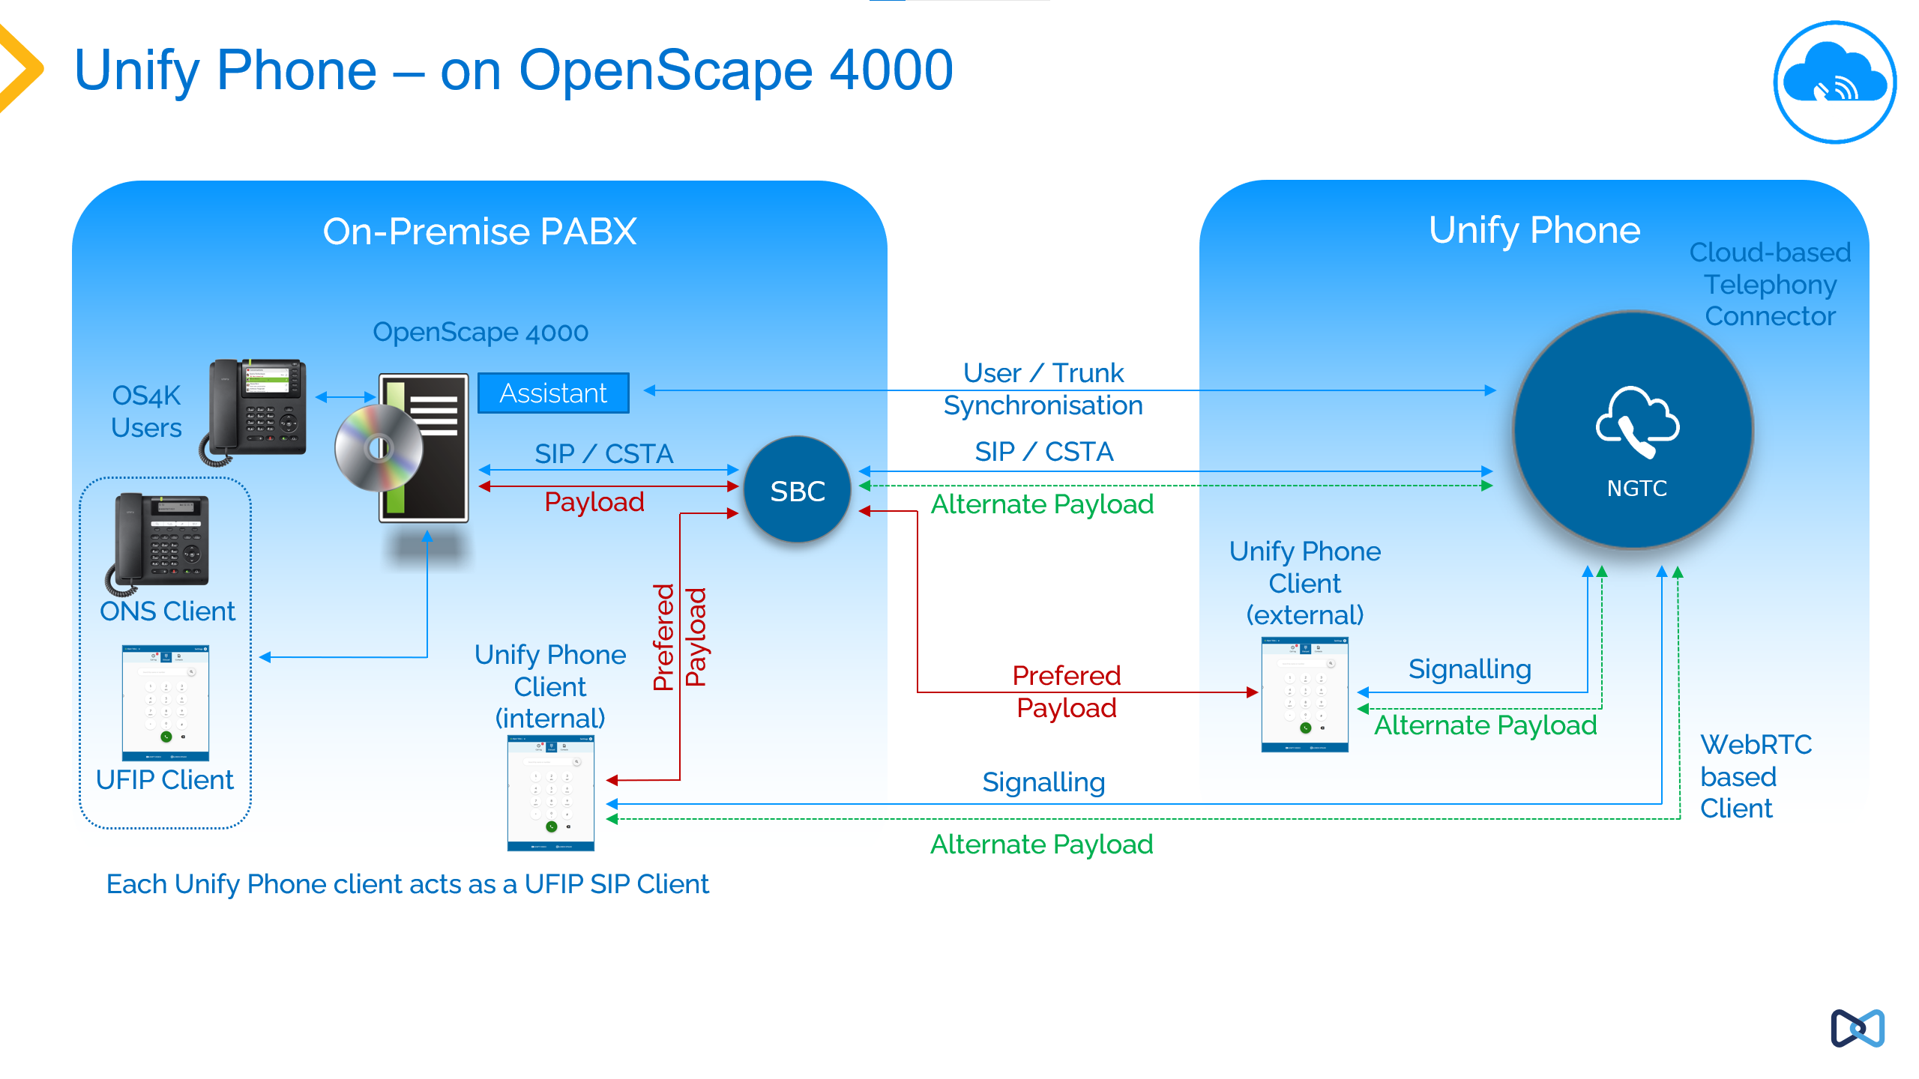
Unify Phone for OpenScape for OpenScape 4000

Licensing
Unify Phone is a subscription service, which has licenses on a price per month per user basis.
There is no capex purchase of Unify Phone licenses possible, customers must always subscribe to the service on a per user basis.
Unify Phone is licensed based on the attached OpenScape Platform, the licenses are linked to the platform using the CLS (Central License Server), these licenses are subscriptions and require ongoing payment of the monthly subscription fee to remain activated.
The license options vary according to the specific OpenScape Platform Involved, see further information below on how this operates.
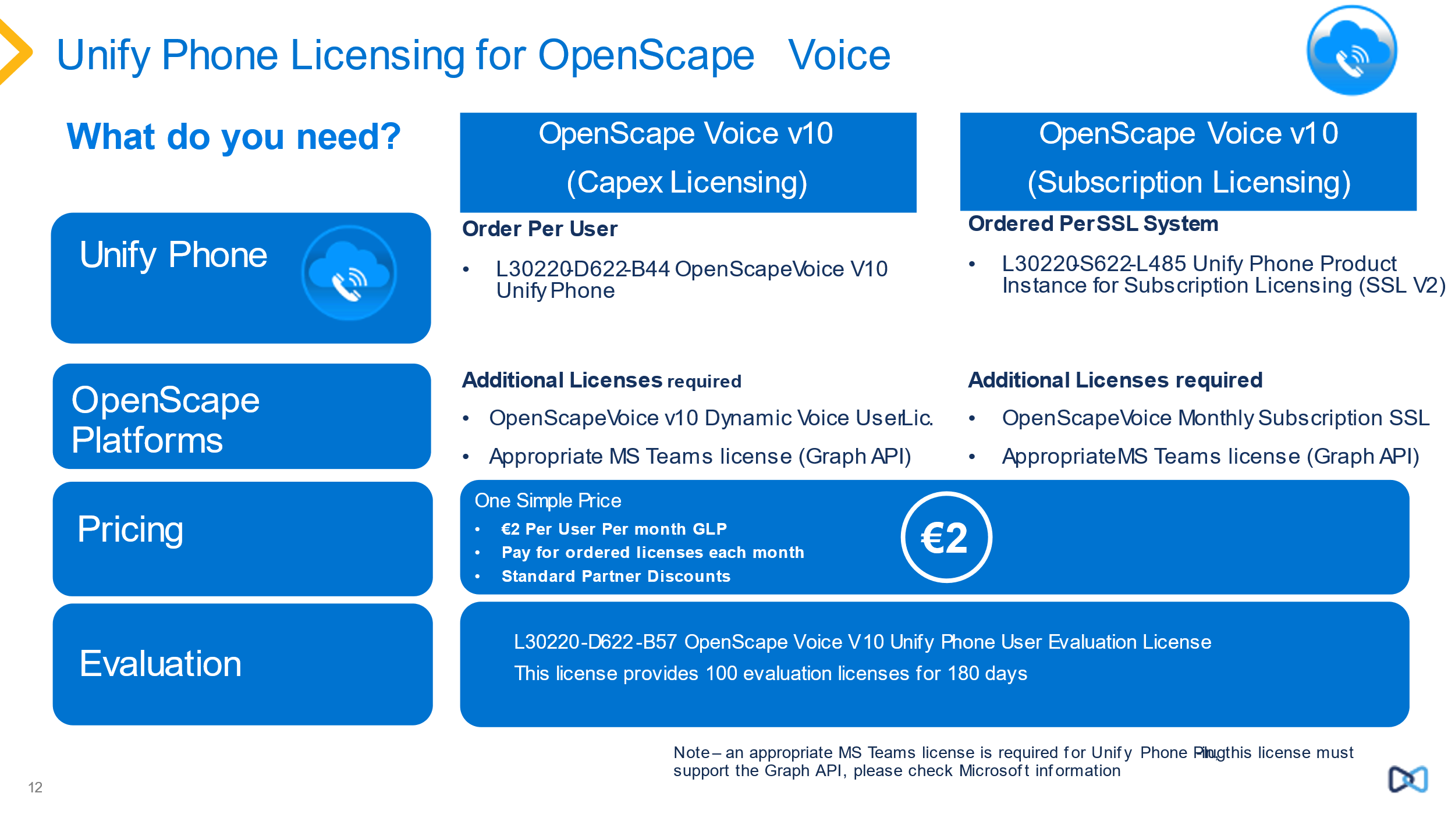
Note - Remote Service Platform or remote access is required for deployment of Unify Phone to ensure consistent support model for a cloud service for OpenScape Business.
An active SSP or software support/maintenance contract on the associated OpenScape system is required for Unify Phone to be supported. In the case of OpenScape Business this is automatically mandated within the system.
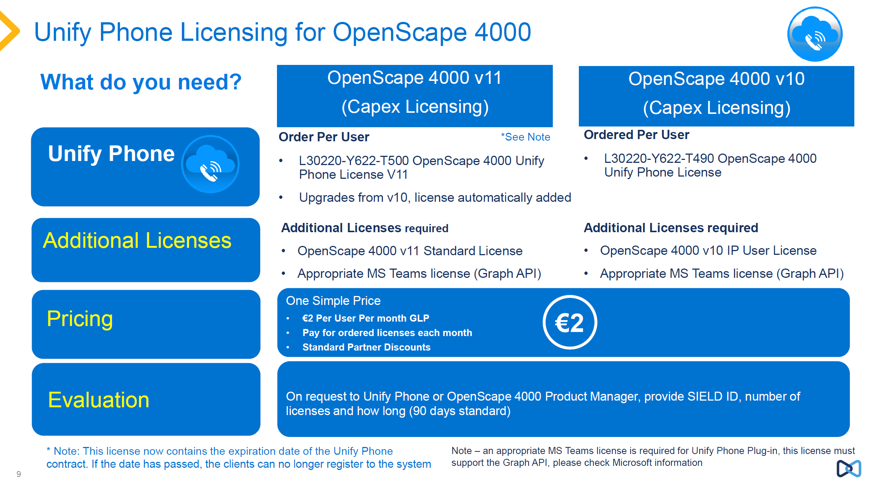

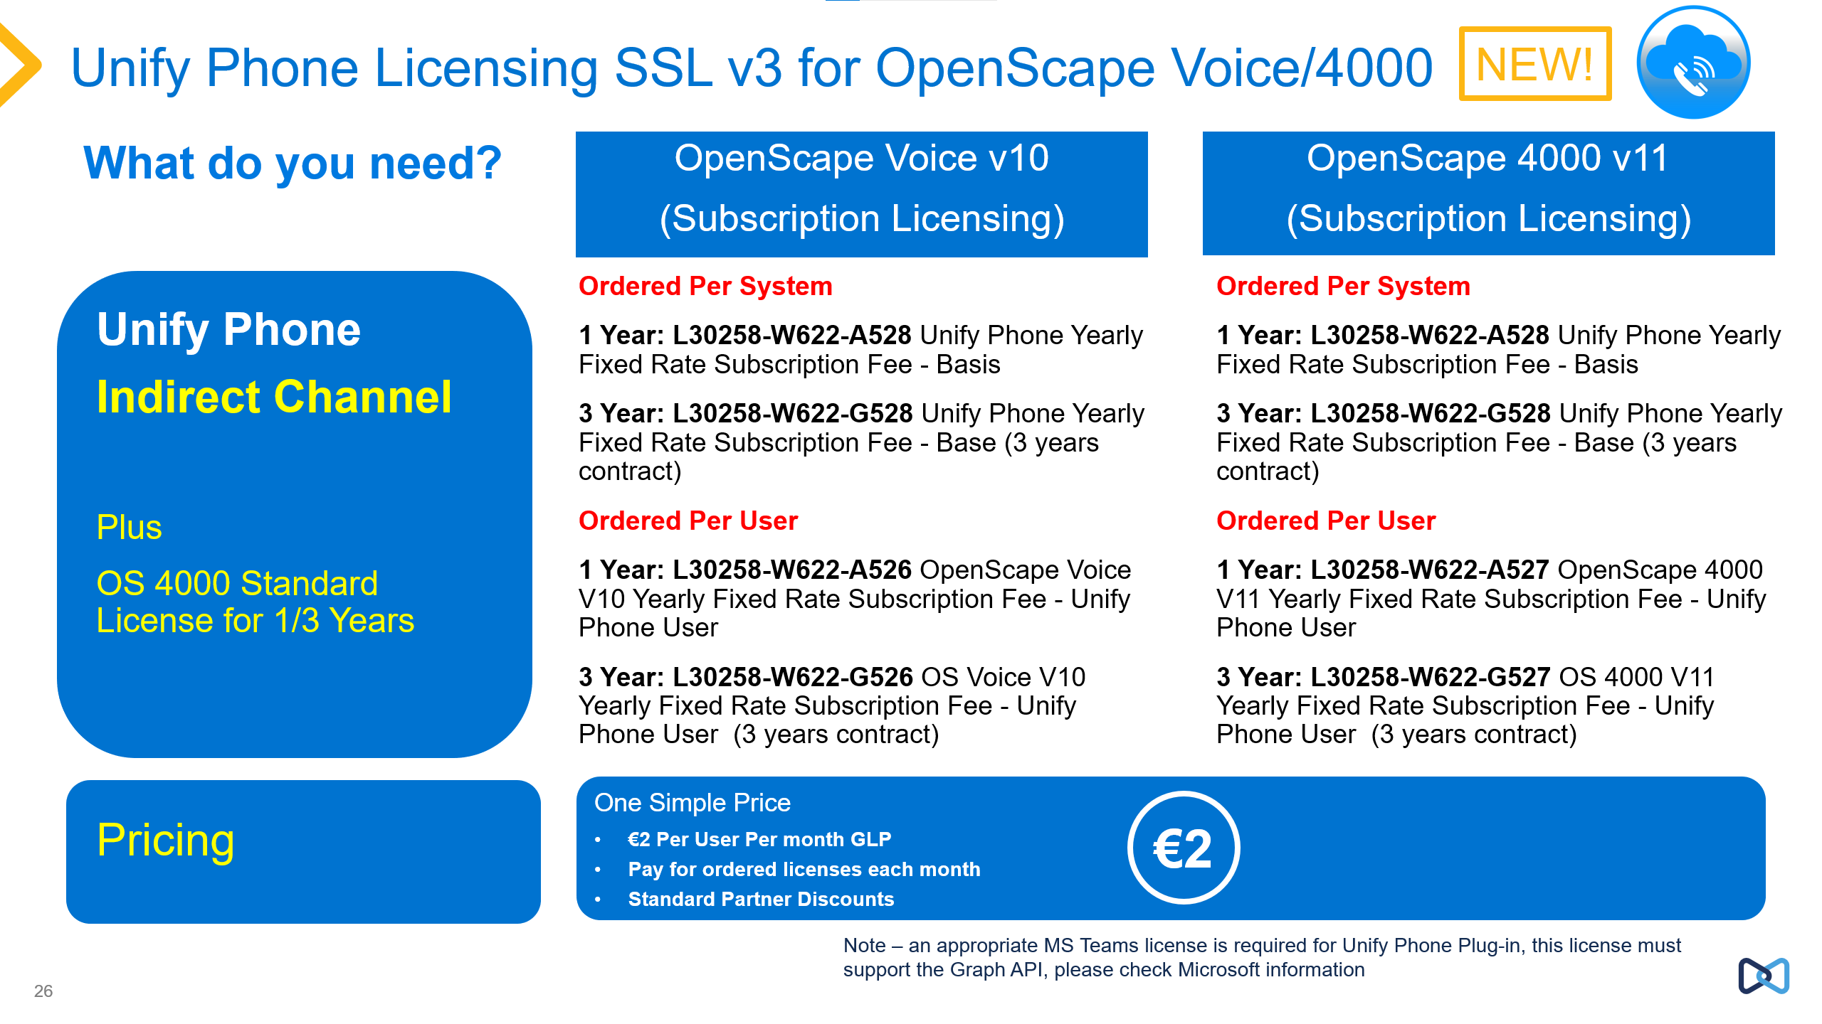

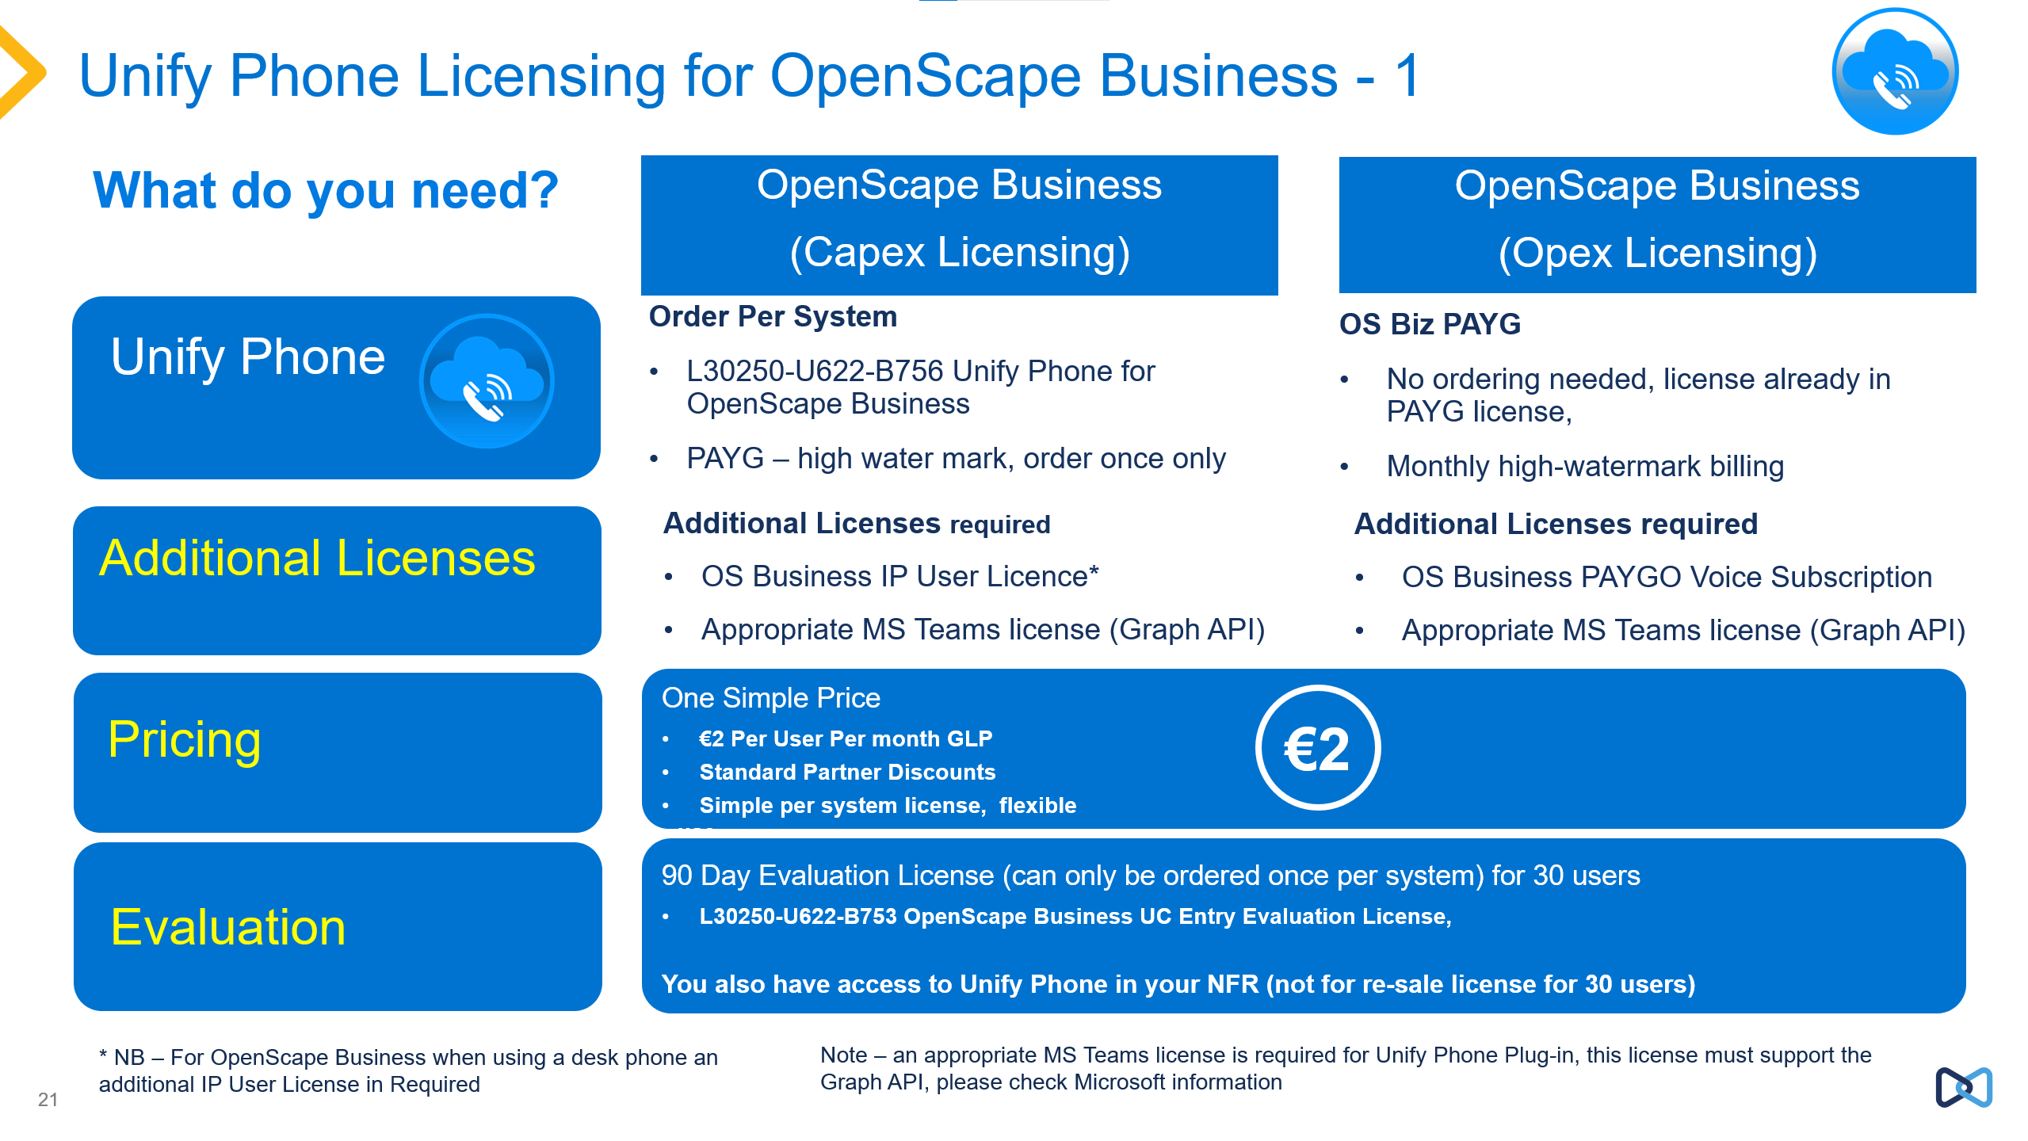

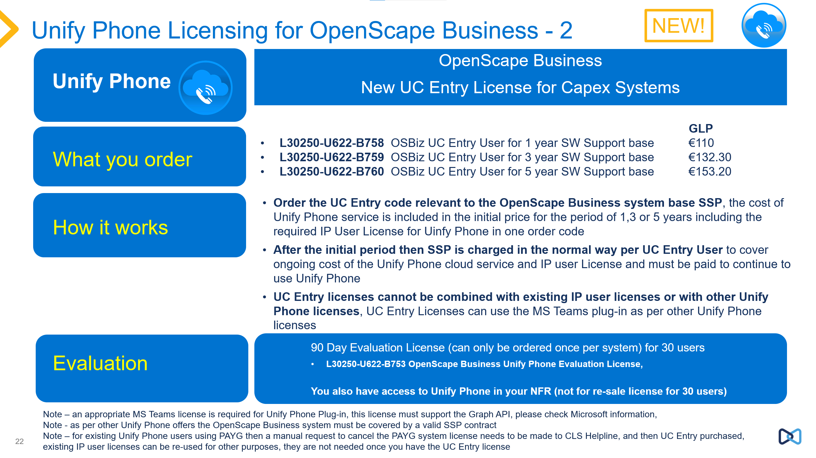

Unify Phone is ordered via CPQ tool, Unify Phone licenses are ordered as subscriptions to be activated or in the case of PAYG (OS Business) and SSL (OS Voice) as licenses which enabled on the platform as configured users.
The billing and invoicing is based on the number of active subscriptions (for SSL/PAYG) or licenses ordered in the case of Capex OpenScape 4000 and OpenScape Voice.
Unify Phone CPQ orders on CPQ-I or CPQ-D follow the normal CPQ process to order in the Unify Processes. Unify Phone is ordered as a configured product (not from the shopping list). For direct channel it should be ensured the subscription licenses are also release on CPQ for the subscriptions to be established. For more information contact your CPQ support.
OpenScape Voice / OpenScape 4000
Unify Phone Licenses to be ordered (per user)
- L30220-D622-B44 OpenScape Voice V10 Unify Phone User License

- L30220-Y622-T490 OpenScape 4000 Unify Phone License (for OS 4000 v10)
- L30220-G622-A224 OpenScape 4000 V11 Standard User License for Unify Phone Upgrades
- L30220-Y622-T500 OpenScape 4000 Unify Phone License V11
- L30220-G622-A222 OpenScape 4000 V11 Standard User License

Note - For Upgrades an upgrade of OpenScape 4000 v10 Unify Phone license to v11 the upgrade license is automatically added.
Important: The OpenScape 4000 Unify Phone License v11 now contains the expiration date of the Unify Phone contract. If the date has passed, the clients can no longer register to the system.
Since the Unify Phone contracts can be renewed, the usage of the "Online Licensing" via the Cloud CLA is mandatory in order to get the new expiration date automatically into the system.

OpenScape Business
Unify Phone Licenses to be ordered (per system)
- L30250-U622-B756 Unify Phone license for OpenScape Business
Or combined with the OpenScape Business order position
- L30250-U622-B758 OSBiz UC Entry User for 1 year SW Support base
- L30250-U622-B759 OSBiz UC Entry User for 3 year SW Support base
- L30250-U622-B760 OSBiz UC Entry User for 5 year SW Support base

The license L30250-U622-B756 is ordered one per system to activate Unify Phone, users can be added or removed as required.
PAYG license for OpenScape Business based on high water-mark license usage per month. For more details see the PAYG (Pay As You Go) document in the OpenScape Business Portfolio Information page.
An active SSP or software support/maintenance contract on the associated OpenScape system is required for Unify Phone to be supported. In the case of OpenScape Business this is automatically mandated within the system.

General Pricing of Unify Phone
The Global List price of the Unify Phone subscription is €2 per user per month, one license per user. The price shown for the Licenses above when you initially order is €0. The charge is for the subscription which follows from the initial order which is billed per month at €2 per month. With OpenScape Business there is the additional UC Entry bundle, which has a one off capex price plus recurring SSP charges after the initial system SSP period which cover the cost of the ongoing Unify Phone charges.
There is no additional charge for the use of the Unify Phone for Microsoft Teams plug-in with Unify Phone for OpenScape.
Note: For OpenScape Business then if the customer system is already under PAYG (Pay As You go) then no licenses is required to be ordered. Unify Phone can be activated on the customer system.
Note: In CPQ you need to create a new separate quote for Unify Phone orders you cannot combine Unify Phone orders with other product orders on CPQ.
Do not order any other license codes than the ones detailed here, such as base licenses, these are inserted by the relevant CPQ system if required. Any pricing you see on these other codes are there for processing in the system and should be ignored.
Unify Phone subscription Charging:
For OpenScape Voice and 4000 the invoicing is on a per monthly basis based on the number of ordered licenses, e.g. if 100 licenses of Unify Phone are ordered then the monthly charge is for 100 users regardless of usage or allocation of those licenses. The charging is based on the number of licenses on the CLS (Central License Server).

Unify Phone with SSL V2 (Software Subscription Licensing)
Please note SSL V2 is going to be phased out in the near future. Customers with SSL V2 in place can use SSL V2 further on, even enhance the number of users, but new customers shall goi for SSL V3.
You order the following product instance using CPQ-I / CPQ-D, this order code is used regardless of whether the SSL is to be used on a Hosted or Enterprise SSL system.
- L30220-S622-L485 Unify Phone Product Instance for Subscription Licensing (SSL V2)

The customer/partner will then be charged per user per month according to the SSL billing guidelines, based on high water mark usage. The use of SSL is subject to the appropriate contract being in place with the customer or partner for use of SSL licenses.
- L30220-S622-L140 Monthly Subscription License Hosted Unify Phone
- L30220-S622-L340 Monthly Subscription License Enterprise Unify Phone
Note: You can use the Product Instance for Unify Phone with Enterprise or Hosted SSL solutions.

Unify Phone with SSL V3 (Software Subscription Licensing)
SSL V3 is a so call fixed rate subscription method. Customers can add new user licenses to the contract. Reduction is possible at the end of the SSL contract period when the contract will be renewed.
With the user has the option to go with SSL for a solution with OpenScape Voice as well as with OpenScape 4000.
For more details, please have a look on the SSL V3 documentation on the partner portal.
For each SSL V3 project you need one SSL Unify Phone base license according to the desired contract period (1 or 3 years) and as many SSL Unify Phone user licenses the customer needs. Find the Unify Phone order positions for SSL V3 in the following lists. Please mention, that you need to order for each Unify Phone user the relevant PBX platform licenses too (not listed here).
SSL V3 - Partner Sales
1 Year:
- L30258-W622-A528 Unify Phone Yearly Fixed Rate Subscription Fee - Base
- L30258-W622-A526 OpenScape Voice V10 Yearly Fixed Rate Subscription Fee – Unify Phone User
- L30258-W622-A527 OpenScape 4000 V11 Yearly Fixed Rate Subscription Fee – Unify Phone User
3 Years:
- L30258-W622-G528 Unify Phone Yearly Fixed Rate Subscription Fee - Base (3 years contract)
- L30258-W622-G526 OS Voice V10 Yearly Fixed Rate Subscription Fee – Unify Phone User (3 years contract)
- L30258-W622-G527 OS 4000 V11 Yearly Fixed Rate Subscription Fee – Unify Phone User (3 years contract)

Unify Phone Evaluation Licenses
Unify Phone also is available for evaluation as follows:
- L30220-D622-B57 OpenScape Voice V10 Unify Phone User Evaluation License
This license provides 100 evaluation licenses for 180 days
- L30250-U622-B753 OpenScape Business UC Entry Evaluation License, this allows for
currently 30 free licenses for 90 days
- For OpenScape Business there is also a Not For Re-Sale (NRF) license which contains 30 Unify Phone licenses
- Unify offers via its accredited Partners an OpenScape Business Pay As You Go NFR (Not For Resale) Base license incl. all available PAYGO license components for up to 30 Users free of charge with no additional monthly fees.
- This offer will be provided once per Partner with an accreditation level in the Unify Partner Program of Authorized, Professional or Master Specialization Level in OpenScape Business. Contact your representative for more information.
For OpenScape 4000 Evaluations Licenses Contact the Unify Phone Product Manager with SIEL ID, quantity of licenses required and how long the trial is to run for, usually 90 days.

Overview Unify Phone order Codes
Please find attached a list of all order codes (L-numbers) which you can find in the tools and what they are for. Not all order codes should be ordered by you – some are for billing/reporting only, while other for internal processing only. If you use for your order those order codes only, which are marked with ‘yes’ in the column ‘to be ordered’.
L-number | to be ordered | purpose | Comment
L30250-U622-B756 | yes | order | PAYG option for OS Business so continues alongside UC Entry
L30250-U622-B759 | yes | order | New UC Entry
L30250-U622-B760 | yes | order | New UC Entry
L30250-U622-B758 | yes | order | New UC Entry
L30250-U622-B715 | no | order | Replaced by high watermark B756
L30250-U622-B752 | no | bill | Used for PAYG Billing based on B756 usage
L30250-U622-B753 | yes | order | Oder code for a POC
L30220-G622-A222 | yes | order | Not a Unify Phone specific license but used in OS 4000 for additional devices
L30220-G622-A224 | yes | order | This is an upgrade for OS 4000 v10 Unify Phone users to move to v11
L30258-W622-B10 | no | order | Is part of the CPQ configurated process, not manually added
L30258-W622-B11 | no | order | Is part of the CPQ configurated process, not manually added
L30258-W622-B12 | no | order | Is part of the CPQ configurated process, not manually added
L30258-W622-B13 | no | order | Is part of the CPQ configurated process, not manually added
L30258-W622-B14 | no | order | Is part of the CPQ configurated process, not manually added
L30258-W622-B15 | no | order | Is part of the CPQ configurated process, not manually added
L30220-D622-B44 | yes | order | Standard OS Voice License (no additional license needed)
L30220-D622-B57 | yes | order | Oder code for a POC
L30220-S622-L140 | no | bill | Part of SSL v2 billing
L30220-S622-L485 | yes | order | Product instance for Unify Phone as part of SSL v2 - to be replaced with SSL V3
L30220-S622-L340 | no | bill | Part of SSL v2 billing
L30258-W622-B20 | no | order | SSL v3, part of setup, billing
L30220-D622-B213 | no | order | SSL v3, part of setup, billing
L30258-W622-A128 | yes | order | SSL v3
L30258-W622-G128 | yes | order | SSL V3
L30258-W622-A528 | yes | order | SSL v3
L30258-W622-G528 | yes | order | SSL v3
L30258-W622-A126 | yes | order | SSL v3
L30258-W622-A127 | yes | order | SSL v3
L30258-W622-G126 | yes | order | SSL v3
L30258-W622-G127 | yes | order | SSL v3
L30258-W622-A526 | yes | order | SSL v3
L30258-W622-A527 | yes | order | SSL v3
L30258-W622-G526 | yes | order | SSL v3
L30258-W622-G527 | yes | order | SSL v3
L30220-Y622-T490 | yes | order | Unify Phone for OS 4000 v10 (needs a IP user license per user)
L30220-Y622-T500 | yes | order | Unify Phone for OS 4000 v11 (need to add OS 4000 v11 Standard License)

User Licenses Required in addition to Unify Phone Licenses
Unify Phone subscriptions do not provide for any additional licenses which may be needed on the platform, it should be check sufficient licenses are provided on the relevant platforms and associated SBCs where required.
- OpenScape Voice requires a OpenScape Dynamic User License (DUL) per configured Unify Phone user, an existing license can also be used for Unify Phone. A DUL is only consumed or used when the Unify Phone client is registered to the OpenScape Voice system (so if off-line no license is consumed).
  - If a DUL is already in use (e.g. for a desk phone), no additional DUL is required when adding Unify phone.
  - Unify Phone, this soft client is connected via the Unify Phone Telephony Connector Cloud Service and registers as a SIP client on OSV. It requires a DUL and a Unify Phone User license on OpenScape Voice.
  - For more information on licenses on OpenScape Voice see the Sales Information for OpenScape Voice.
- OpenScape 4000 v10 requires a OpenScape 4000 Flex License per configured Unify Phone user, an existing license, can be re-used for Unify Phone if available. This changes in OpenScape v11 as below.
- For each OpenScape 4000 v11 User:
  - IP or TDM desk-phone Flex License: L30220-G622-A221
  - Unify Phone Standard License
Unify Phone License
- For OpenScape Business required an OpenScape Business IP User License (note if using a desk phone in addition a further OpenScape Business IP user License is required.
- Additional SBC Channel Licenses may be required as active Unify Phone telephony calls consume SBC channel licenses.
For OpenScape Voice, OpenScape CMP can be used to manage users, individual users can be configured using OpenScape CMP User Manager without the need for UM licenses, but more bulk features are available if UM licenses are used, therefore UM is recommended.
Note: Please check Sales Information for the respective platforms and applications for more information on licensing required.

SBC Requirements
OpenScape Voice and OpenScape 4000 requires use of OpenScape SBC to provide the connection to the Unify Phone service with the required number of available SBC session licenses. An SBC license is required for each active Unify Phone call.
- An existing OpenScape SBC can be used, and licenses shared between Unify Phone users and other SBC use cases.
- For OpenScape Business no SBC is required.
- Currently there is no support for third party SBCs e.g. Audiocodes, Oracle with Unify Phone.
Some useful Frequently Asked Questions to help understand where use of OpenScape SBC licenses are required:
Note these licenses are only consumed when the Unify Phone user is on an active call, no licenses are consumed if the Unify Phone user is not on an active call.
When a Unify Phone user makes an external call do I consume two SBC licenses?
Answer: Two SBC licenses will be used. One for the Unify Phone part and one for the external call part of the call.
When I receive an external call?
Answer: Two SBC licenses will be consumed, one per each leg of the call, one for the inbound call and one for the call to the Unify Phone client.
What number of SBC licenses are used when a Unify Phone user calls another Unify Phone user?
Answer: Two SBC licenses are required because there will be two connections to the SBC, one for each Unify Phone device.
When an internal desk phone user calls a Unify Phone user?
Answer: If the internal desk phone is inside the customers network on the OSV, only 1 SBC license, for a call from the Unify Phone user to the internal desk phone again one SBC License is consumed.
If the desk phone is external to the customers OpenScape Voice network then two SBC licenses are consumed, one used by the desk phone and one used by Unify Phone.

Effectively UP users should be considered as remote subscribers with traffic considerations for both Internal and external calls requiring OpenScape SBC licenses on the SBC for both types of Calls. A UP user calling either an OSV user or PSTN or another UP user will consume Session licenses as detailed above.
Therefore, when considering the number of UP licenses you need to take into account the grade of service require for Internal, Interswitch and PSTN calls to size the number of session licenses required on the SBC.
The general rules for SBC as below, please consult the OpenScape SBC Admin Guide for more information.
An OpenScape SBC Session License is required for the following:
- OpenScape SBC - Internet connections
- OpenScape SBC - SIP Trunking and Remote Subscribers
- OpenScape Branch - SBC Proxy - SIP Trunking
- OpenScape Branch - Branch SBC - SIP Trunking

User Management
User Management is a key consideration to the Unify Phone solution, there is a user management solution for Unify Phone for OpenScape. See later section on Services to discuss the FLIP tool which can be used for bulk migrations of users to Unify Phone for OpenScape.
For Unify Phone for OpenScape for OpenScape business a bulk import of users can be done using a MS Excel file.
Please consult the Unify Phone tenant administration guide for more information, and in the administration of OpenScape Business, OpenScape 4000 and OpenScape Business.

User Management Unify Phone for OpenScape / MS Teams
For Unify Phone for OpenScape, the user identity and management is provided by the Unify Phone. Users are created and defined within the Unify Phone system, and this identify contains a telephone number which is used to synchronise with Unify Phone telephony user created using the relevant OpenScape platform.
Once the users are created on the platform they are created on the Unify Phone database as users which then match the users setup on Unify Phone by the FLIP Tool or using the MS Excel CSV file imported using the Tenant Admin Panel of Unify Phone for OpenScape.
For more information on the setup of Unify Users on OpenScape platforms please consult the sales and administration information for the respective platform.
OpenScape Common Management Portal User Management (UM) can be used to add individual users to Unify Phone for OpenScape without the need for dedicated UM licenses. For more advanced UM features then UM licenses are required, see CMP UM product information for more details.
Unify Phone for OpenScape users use their Unify Phone login name/password or Unify Phone for OpenScape can be configured for Single Sign On (SSO).
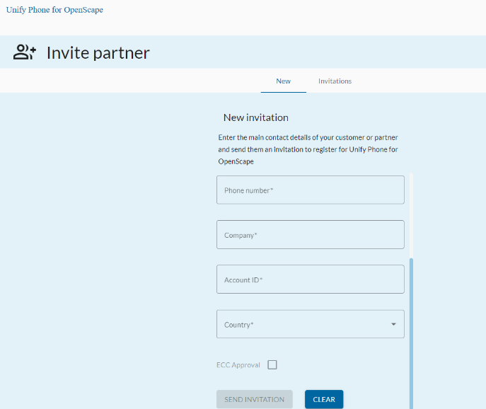
Invite customer form
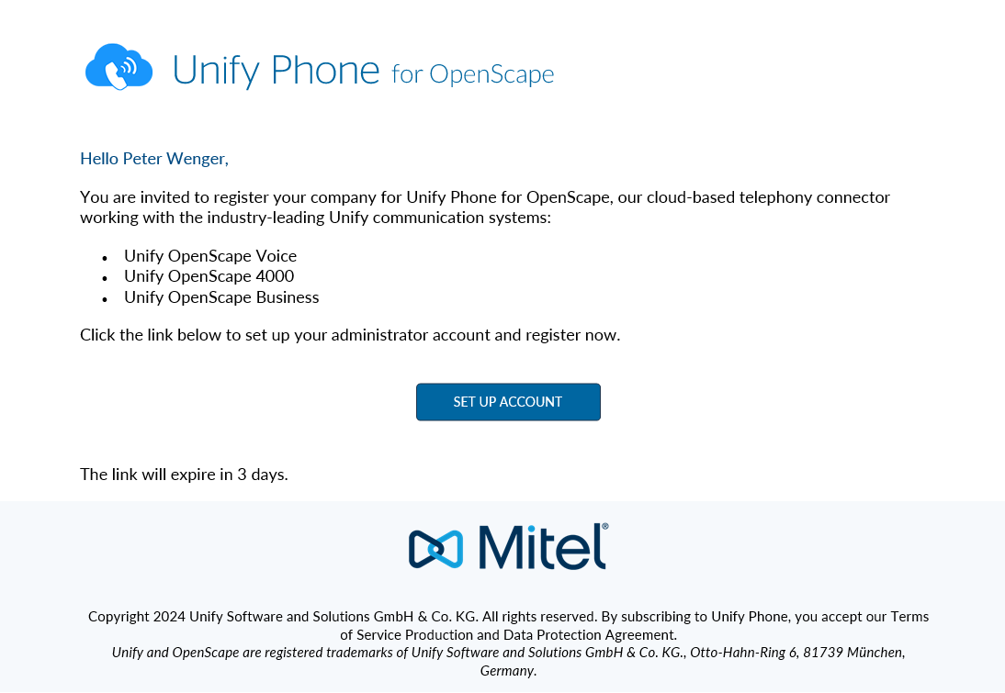
Initial invite mail to the customer admin
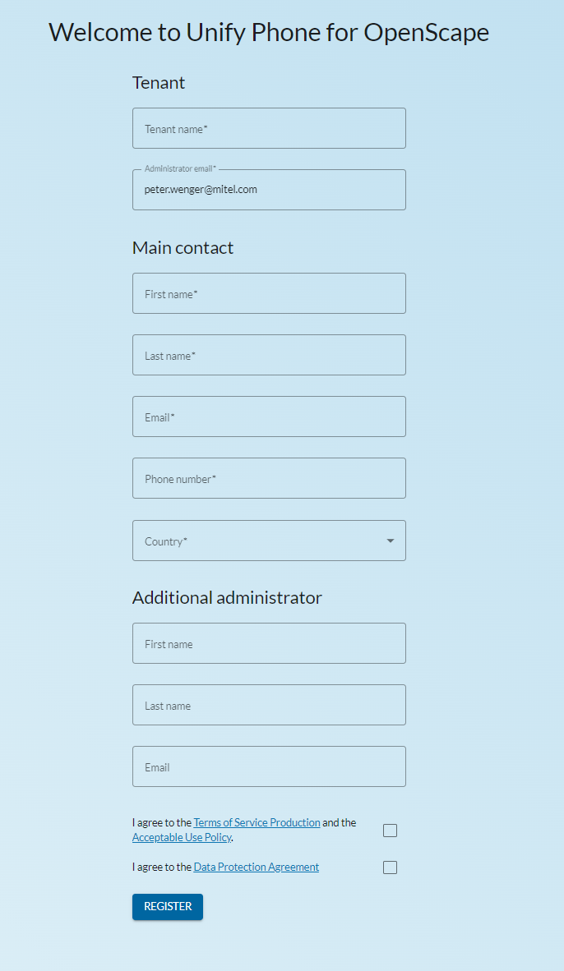
Registration of the customer’s admin incl. option for partner/additional admin
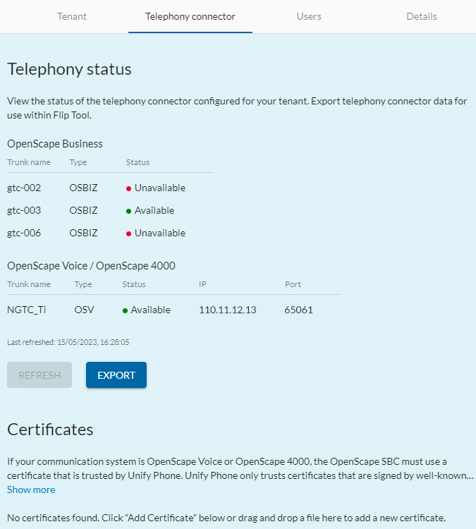
Status of the Telephony Connectors (here mixed PBX to one Unify Phone tenant)

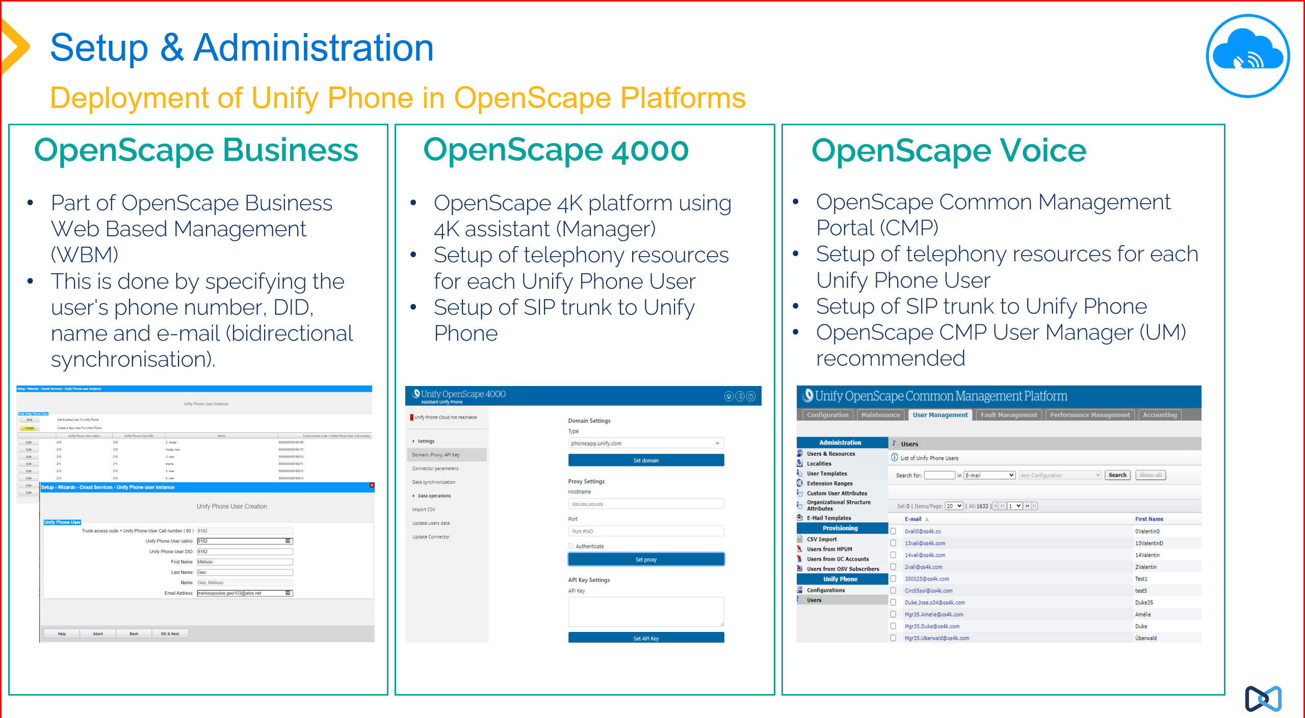
Administration of Unify Phone in OpenScape

Security
Extract the Unify Phone Security document which can be found in the portfolio pages of Unify Phone.
Note – end to end payload encryption is not currently available for OpenScape Business
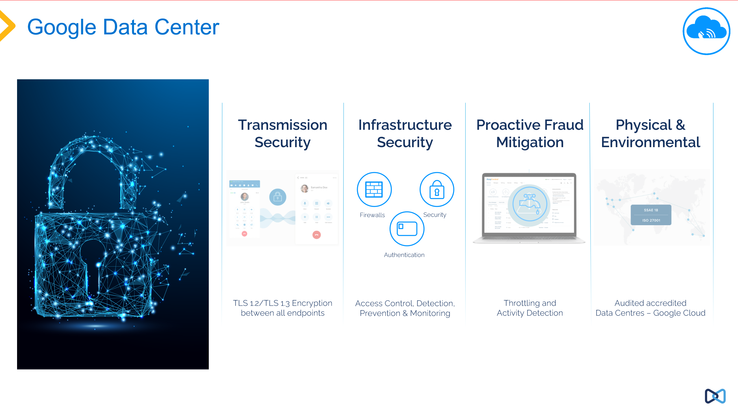
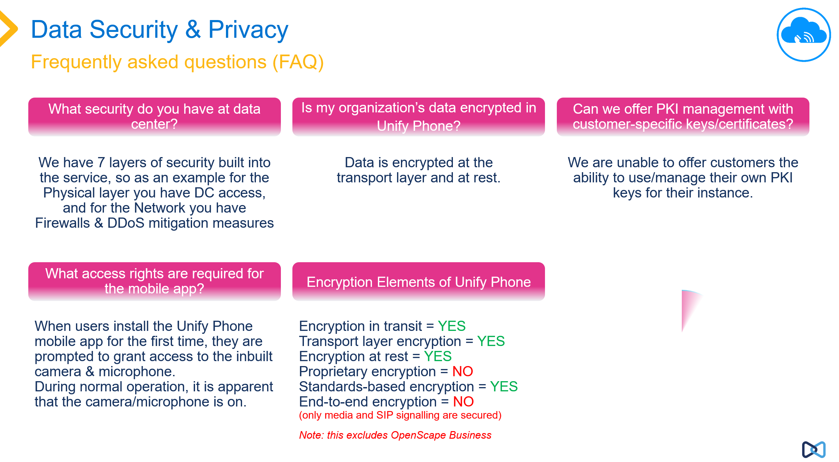

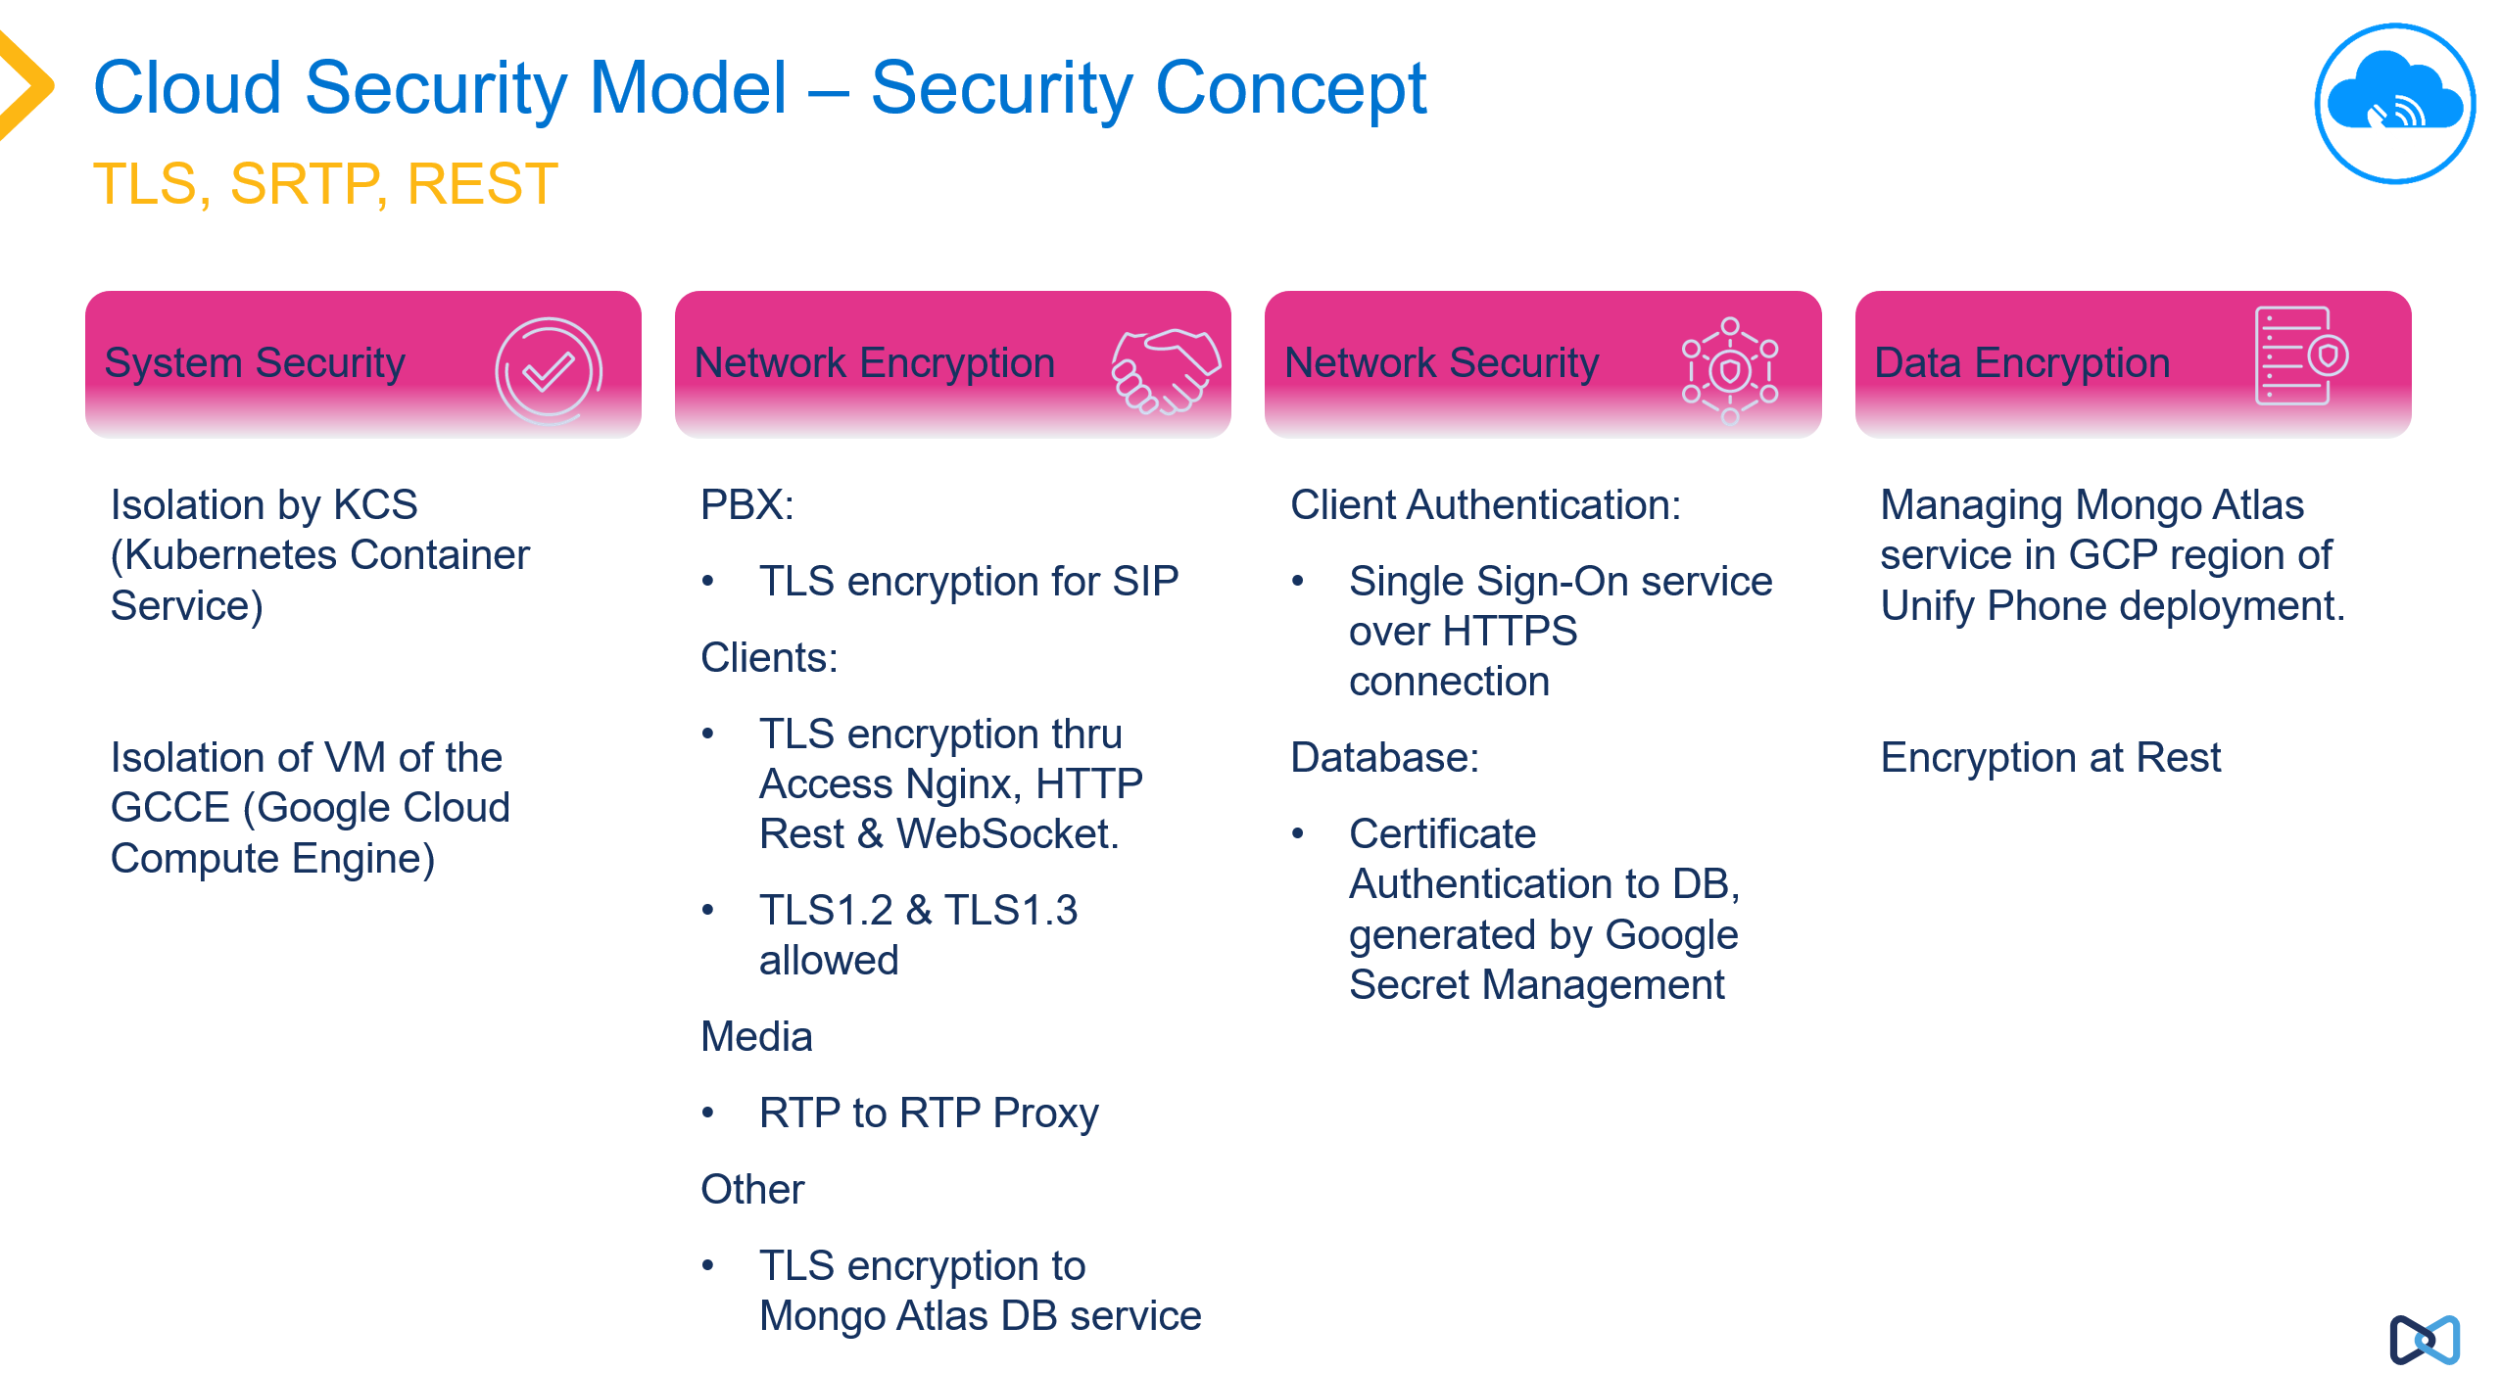

Networking Requirements
As Unify Phone requires a capable network environment for operation from desktop and mobile devices then the following pre-requisites should be noted and ensured in place by the end customer:
- VOIP readiness, for network and WLAN
- QoS with priority for VoIP traffic on network and WLAN
- Sufficient bandwidth & transparent routing of VoIP traffic between sites, core SBCs.
- If WIFI/WLAN is used, sufficient signal strength/coverage for VoIP & seamless roaming needs to be assured.
- Network and WLAN assessments should be carried out to ensure the network is able to support the real time nature of the Unify Phone service.
It should be planned and ensured the required operating model for Unify Phone in the customers network and it’s remote users is in place to avoid operational problems with Unify Phone by end users of the service.

Migration
There is only one supported version of Unify Phone which is the latest as provided by the Unify Phone Cloud Service. All users are automatically on the latest version of Unify Phone. The clients are updated automatically, and new versions of mobile clients updated from the app stores, when users select auto-updates their mobile devices are automatically updated.
Other possible migrations may be from using Unify applications such as Personal Edition, MyPortal-to-Go, OpenScape Mobile where customers are looking for a cloud based telephony client to use with their OpenScape platform.
A migration from Circuit/ Circuit Telephony Connector is also possible to Unify Phone for OpenScape if telephony capability is only required by the customer.
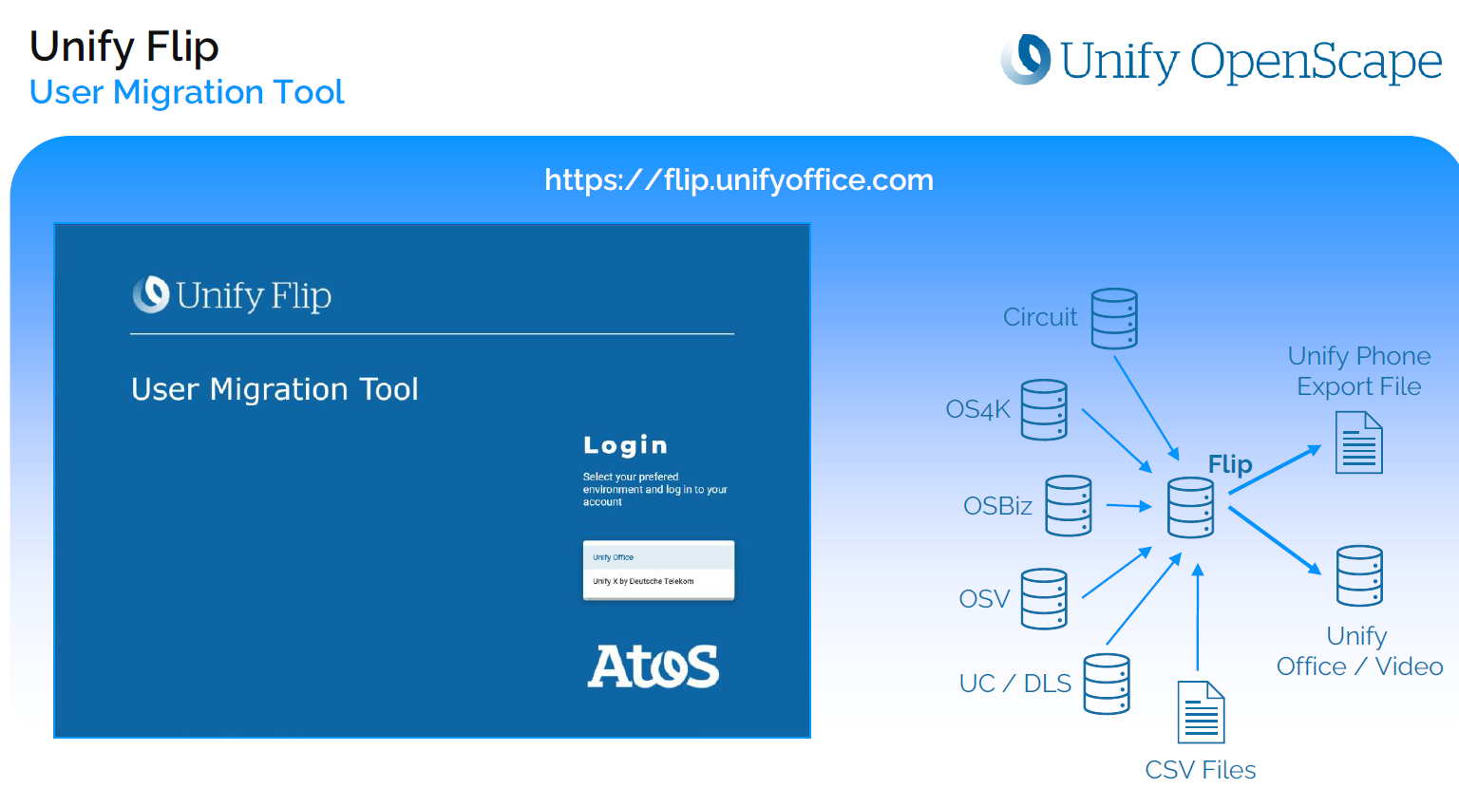
Unify Developed the FLIP Tool to enable mass migration of users

Unify Management Center (UMC)
Unify Management Center (UMC) is a centralized platform designed for managing multiple customers Unify phone tenants, connections, and users.
- Centralized Management: UMC allows administrators to manage multiple Unify phone tenants and their settings from a single interface with a single account.
- Simplifies tenant creation: With UMC partners can easily create a list of their customers and assign existing tenants or create new one with a few steps. (available only for EU/UK)
- Trunk/Connection Management: UMC can create, edit or delete Unify Phone connections to local PABX based on the PABX type (released for OSBiz only)
- User Management: It provides tools for managing user accounts for Unify Phone. Administrators can add or remove users, assign extensions, and configure individual settings or mass provision users.
- Auditing and Reporting: UMC offers auditing capabilities to track the provisioning actions that have taken place in each tenant and which UMC Administrator did it.
- Troubleshooting and Support: Partners can easily troubleshoot Unify Phone issues from a single interface for all their customers with Unify Phone service activated.
- Security and Compliance: UMC includes features to ensure the security and compliance of the application data, including user authentication, access controls, and encryption.
Overall, Unify Management Center is designed to simplify the management of Unify's phone tenants, enhance operational efficiency, and provide a unified approach to communication system administration.
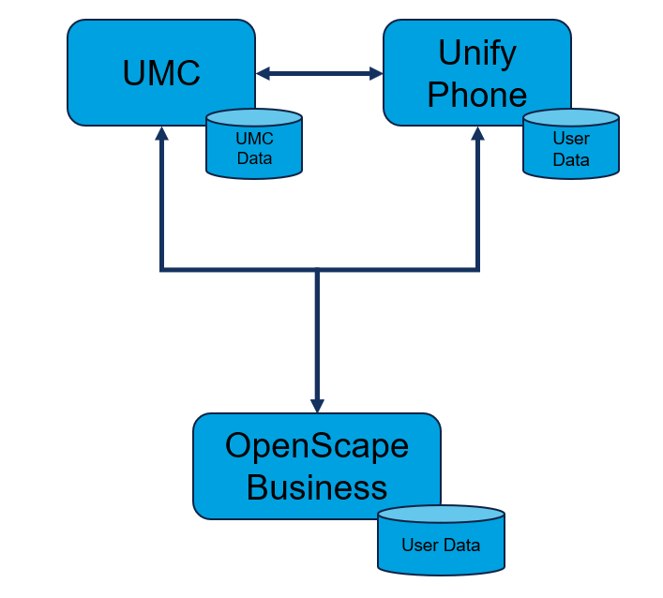
UMC targets resellers and distributors with a multi-tier access management.
UMC won’t be given to customers. Please keep this in mind, as there is a simplified approval process e.g. regarding Export Control during the sales process.
To get UMC the Tier-1 partner or distributor uses the onboarding request form:
- Unify Phone - Instruction UMC Account Request Form for Partners
Partner can find this form on the partner porta. Partners are asked to fill the form and send it to their Mitel contact (CAM/DAM).
The CAM/DAM double checks whether all fields are filled and forwards the form for onboarding.
Distributor can then onboard their partners to UMC.
Mitel requires full Primary Partner Administrator company name and full address to comply with Export Control (ECC) Regulations. The SLA from the point of receipt of the request to provision of the invite email is 48 hours (CE business hours)
Please note: Partners in EU and UK can do the tenant creation by themselves. Partners outside of EU / UK need to approach the Mitel contact (CAM/DAM) for tenant creation.
UMC comes without a license fee.

Services
Unify Phone is a cloud-based service, the overall solution is a combination of the solution elements:
- OpenScape Business v3R3 (No additional SBC Required)
- OpenScape Voice v10R3 with OpenScape SBC v10R3 or OpenScape SBC v11R0
- OpenScape 4000 v10R1 with OpenScape SBC v10R3 or OpenScape SBC v11R0
- OpenScape 4000 v11R0 with OpenScape SBC v11
- Unify Phone Clients (web, progressive web application, mobile)
- Unify Phone Plug-in Unify Phone for Microsoft Teams
- Unify Phone Tenant Administration
- Unify Phone Back-End Service
See Product and Services Guide for services relating to Unify Phone Clients and Back End Services.
- Unify Phone Product and Service Description, User and Administration located Unify Phone Portfolio Homepage
- OpenScape Business Service information located OpenScape Business Portfolio Page

Support Services
Unify Phone is supported by Unify as part of an overall set of cloud and hybrid cloud solutions.
Unify Phone is a wholly developed and supported solution from Unify.
In terms of support models then Unify Phone is deployed and attached to the OpenScape platforms. It is a cloud based subscription service. The costs of service support for Unify Phone is included in the monthly price per user subscription.
From a support perspective we have the following elements
- Unify Phone deploy consisting of
  - Unify Phone clients (web, progressive web app, mobile)
  - Unify Phone Cloud (the back end Unify Phone cloud service)
- OpenScape Platform (OpenScape Business, OpenScape Voice, OpenScape 4000)

Overview of Unify’s Cloud and Hybrid Solutions
Partners would utilise their existing SSP based contracts for OpenScape platforms but would add Unify Phone to their end customer contract, to provision for this an amendment to the existing OpenScape SSL/PAYG contract has been made which partners have to adopt, in additional to a new reseller contract addendum to provision for the case of Unify Phone.
According to this support model we define demarcation of responsibility to ensure the most efficient support for partners and their customers.
Mainly this concerns the need for a partner to ‘triage’ and offer ‘incident’ support to their customers, in taking responsibility for the OpenScape platform, Unify Phone client and connectivity.
Once it has been determined that there is a problem with the Unify Phone cloud service, the incident must be opened on the corresponding Unify Phone subscription contract. This does not preclude a partner from creating problem tickets for the OpenScape platform and Unify Phone clients..
Support from Unify is using the expected L1, L2 and L3 processes, in the case of Unify Phone Unify maintains a DevOps (Development Operations) function which is responsible for the support of the Unify Phone cloud service including monitoring, pro-active management and communications around service problems and incidents.
More information on the Services provided with and for Unify Phone contained the relevant service documents provided for contracting and in the Unify Phone Portfolio pages.

Positioning in Relation to Products in the Unify Product Range
Unify Phone forms part of an overall hybrid solution offering for Unify Customers. Unify Phone complements other Unify Portfolio Elements providing a hybrid solution between premise and cloud and is the ‘Expand’ option as shown below.
Unify Phone for OpenScape and Unify Phone for Microsoft Teams are some of the hybrid migration paths for customers and complements our OpenScape Platforms and allows customers to retain their platform and associated devices to that platform.
We offer migration pathways for customers to move from premise, hybrid to full cloud deployments.
With the release of Unify Phone for OpenScape the further integration of Unify Phone with other Unify applications will be possible in the future. See our roadmap for further details.

Sales Information

Area of Application, Commencement of Marketing and Delivery

Customer Information on Commencement of Marketing and Delivery
As a customer of Unify Software and Solutions GmbH & Co. KG, you can obtain further information about this from your country specific Unify organisation.

Sales Objectives and Target Groups

Target Group
Unify Phone is suitable for direct and indirect channel customers.
Unify Phone for OpenScape provides a cloud telephony solution for all OpenScape customers. We target existing and new OpenScape customers with both Unify Phone releases.
We also now release Unify Phone for Microsoft Teams, this provides even further integration of a cloud solution, in this case Microsoft Teams within our OpenScape platforms, further extending use of Unify OpenScape platforms for customers.
Below we show some typical customer scenarios where Unify Phone can provide a solution to those customers’ requirements for a hybrid solution.
Benefits of Unify Phone for OpenScape for customers

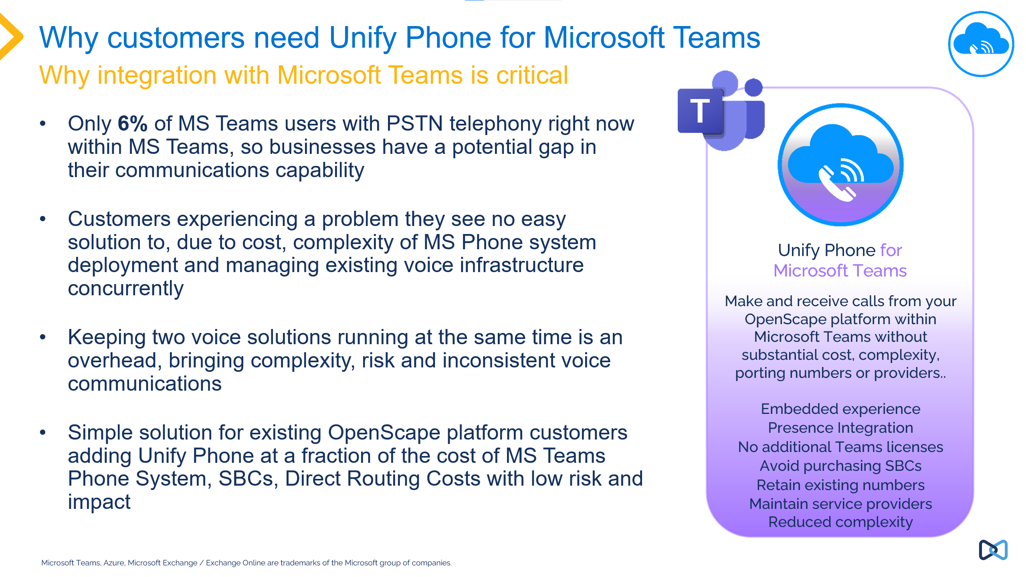
Benefits of Unify Phone for Microsoft Teams for customers

Marketing Structure
See section Licensing for more information on the offer.

Supporting Sales Information

Supporting Sales Information on the Internet
The complete product documentation is available on the Unify Partner Portal:
http://www.unify.com/us/partners/partner-portal.aspx
For other language versions, please contact your country-specific organization.

Prices and Contract Processing
As a customer of Unify Software and Solutions GmbH & Co. KG, you can obtain further information about this from your country specific Unify organization.

Export regulations
Certain products in our sales program are subject to the regulations governing export permits required under EU / German / US law [in accordance with the Export List (in German ‘AL’) and Export Administration Regulations (EAR)].
At the time of an offer/bid or order confirmation you can’t be sure that
• the required export license will be granted in every case
• the validation of existing export licenses covers delivery times that can arise out of unexpected delays.
If, therefore, you are aware, or if you may assume, that what you are supplying to your customer is intended for export or re-export – including indirect export and transactions with dealers – you must ensure that the following reservation is included in your quotation, order confirmation, or contract, as the case may be:
„This offer (contract, order-confirmation) and fulfilment of contract are subject to the provision that required export licenses have been granted and there are no other impediments arising from German or other export regulations “

Data Protection

Client Information on Data Protection and Information Security
The respective country-specific provisions regarding data protection must be complied with.
For Unify Phone standard TOSP (Terms of Service Product) and DPA can be found here (applies to all customers direct and indirect except by agreed exceptions. Within the TOSP, other key contractual elements are defined e.g. Acceptable Use Policy, EULA (End User License Agreement).
In EN:
https://unify.com/en/legal-information/unify-phone/terms-of-service-production
https://unify.com/en/legal-information/unify-phone/dpa
In DE:
https://unify.com/de/impressum/unify-phone/allgemeine-nutzungsbedingungen
https://unify.com/de/impressum/unify-phone/datenschutzvereinbarung

Training Concept

Client Information on the Training Offer
As a customer of Unify Software and Solutions GmbH & Co. KG, you can obtain further information about this from your country specific Unify organization.

Information on our training offerings can be found at the Unify Academy Portal: https://academy.unify.com/

Information on the Training Offer
Information on our training offerings can be found at the Unify Academy Portal: https://academy.unify.com/

Appendix
Abbreviations / Terms | Explanation
Product | In this document, represents hardware/software services and solutions
Unify Phone | Unify Phone is Unify’s hybrid cloud based telephony connector solution, allowing use of mobile and web clients with OpenScape platforms, users can also combine Unify Phone with other applications such as Microsoft Teams
Progressive Web App | PWA is a way to deploy apps which are based on a browser such as Google Chrome which can be used like an app, they can be automatically started but do not need to be deployed and management as a normal windows application
Hybrid Cloud | A way of combining premise/hosted solutions with cloud solutions providing an integrated end user experience and capability
Subscription | Offerings which are bought and paid based on a regular payment for usage, the offering is never purchased or owned but only available for use once the ongoing payment for subscription is being made
Custom App (Microsoft) | This is a method to provide to Microsoft Teams users an application which is not native to MS Teams or MS Teams store. It is a manual method to provide applications which end users can then add to their Microsoft account
PAYG (Pay As You Go) | This in the context here is the Unify solution for flexible licensing on OpenScape Business, this model is used either for a full system or to support Unify Phone on a cap-ex system. PAYG has a specific contract attached to it, and the mechanism is automated based on monthly usage which is captured from the live customer system and the results used to generate invoices to the distributor/partner for license usage.
PSR | Project Specific Release
NGTC | Next Generation Telephony Connector, this is the former names of Unify Phone but also is used to discuss the back end services of Unify Phone where the concept of a telephony connector is relevant to the connection from Unify Phone (NGTC) to the OpenScape system connected to it.
Presence Synchronisation | In the context of Unify Phone for Microsoft Teams, this is the bi-directional presence synchronisation between Unify Phone and MS Teams where the different presence states possible are mapped to one another. The provides a more joined up customer experience when using both MS Teams and Unify Phone they can see one presence and know the status of other people in MS Teams/Unify Phone
Microsoft Azure | The Microsoft Cloud platform where customers access Office 365, MS Teams and other Microsoft applications and also provides interfaces e.g. the Graph API which allows third party applications such as Unify Phone to connect


© 2024 Mitel Networks Corporation. All Rights Reserved. Mitel and the Mitel logo are trademark(s) of Mitel Networks Corporation. Unify and associated marks are trademarks of Unify Software and Solutions GmbH & Co. KG. All other trademarks herein are the property of their respective owners.

© Copyright 2018, Mitel Networks Corporation. All Rights Reserved. The Mitel word and logo are trademarks of Mitel Networks Corporation.
Any reference to third party trademarks are for reference only and Mitel makes no representation of ownership of these marks.

© Copyright 2018, Mitel Networks Corporation. All Rights Reserved. The Mitel word and logo are trademarks of Mitel Networks Corporation.
Any reference to third party trademarks are for reference only and Mitel makes no representation of ownership of these marks.

© Copyright 2018, Mitel Networks Corporation. All Rights Reserved. The Mitel word and logo are trademarks of Mitel Networks Corporation.
Any reference to third party trademarks are for reference only and Mitel makes no representation of ownership of these marks.
mitel.com

mitel.com

mitel.com

mitel.com

